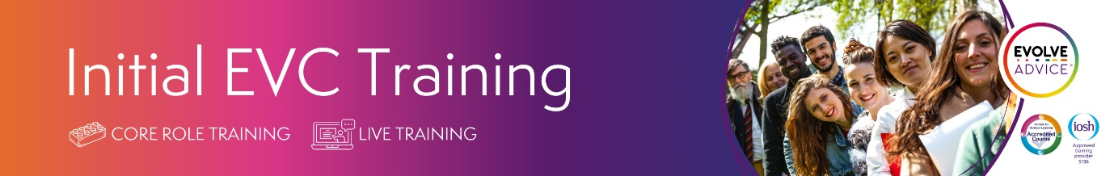
Part 1: 3 hours self-guided e-learning module
Part 2: 3 hours live online session via zoom
Date and time for Part 2: Thursday 26th November, 9.30am – 12.30pm
EVC certification is awarded on the successful completion of both parts.

Initial EVC Training from EVOLVE Advice is a comprehensive training course for new EVCs. The course provides essential training on the responsibilities of an Educational Visits Coordinator, and how to fulfil them, including: supervising off-site activities, risk management, and planning educational visits.
DfE guidance states that Schools should appoint an educational visits coordinator and make sure they have the training they need. EVCs are responsible for the safety and educational outcomes of children and young people on educational visits. It can be an isolated role, and one that carries a lot of responsibility for health and safety and compliance with relevant guidance, including OEAP National Guidance. Initial EVC Training provides you with the relevant knowledge and skills to be a competent EVC. You’ll also have the opportunity to ask questions and get practical advice to help you in your role.
This course has been mapped against the core competencies set out in OEAP National Guidance. It was developed by advisers who have completed OEAP Course Director Training (train the trainer).
Course content includes:
- Educational Visits Context
- Planning, Leading and Evaluating Visits
- Importance of Monitoring
- Risk Management
- Competence
- Supervision
- Guidance
- Best Practice
- Legal Issues and Expectations
The course content is informed by our Educational Visits Advisory Panel, which includes advisers with current professional accreditation, including individuals who hold personal accreditation with OEAP/AAOLEV.
Initial EVC Training is a full 6-hour blended course for new EVCs, those who are returning to the role, and EVCs who want to achieve the IOSH Approved Educational Visits Coordinator certification. EVCs who have completed training within the last three years can revalidate their training and get the latest updates at our dedicated EVC Revalidation Training.
Initial EVC Training is also recommended for EVCs who have not completed EVC Training within the last three years. Experienced EVCs looking to refresh their training on the recommended three-yearly cycle are encouraged to choose EVC Revalidation Training.
Please note this is not training on the use of the EVOLVE system

