2020 Early Years Transition

Challenge booklet
Contents
Introduction
Challenge 1: Grow your own beanstalk
Challenge 2: Nature hunt
Challenge 3: Counting objects at home
Challenge 4: Shape hunt
Challenge 5: Story time

Introduction
In this pack are a number of activities that children might like to do, at home with their parent/carers and siblings or at school in their ‘bubbles’. They are designed for children in Reception and Year 1, but could be used with children joining Reception classes in September or across KS1

We hope you enjoy them.

Challenge 1: Grow your own beanstalk
Here is a fun activity you could do while you are at home waiting to be able to come back to school. Why not try and grow your own beanstalk? When you come into school we can see who has the tallest beanstalk or you might be able to share pictures of your beanstalk with the class from home.
Record how tall your beanstalk grows
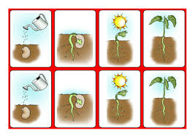
In the table below record how tall your beanstalk has grown by drawing pictures or adding photographs.
Number of days after planting | Drawing/photo
Day 2
Day 4
Day 6

Challenge 2: Nature hunt

Here is a fun activity you could do at school or while you are at home waiting to be able to come back to school.
Go on a nature hunt and look for something:
round | shiny | rough
smooth | soft | dull
brown | green | moving

Now draw them in the boxes below

round | shiny | rough
smooth | soft | dull
brown | green | moving

Challenge 3: Counting objects at home
Here is a fun activity you could do at school or while you are at home waiting to be able to come back to school.
How many of these things can you find and count around your house? Add your own ideas in the empty boxes
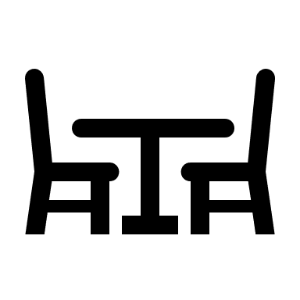  chairs | spoons | books | shoes
hats | socks | balls | people

Now can you sort them into groups/categories? Do some belong in more than one group/category?

Challenge 4: Shape hunt
Here is a fun activity you could do at school or while you are at home waiting to be able to come back to school.
Can you find objects that look like:

Square | triangle | circle
Rectangle | hexagon | pentagon

How many sides do these shapes have?
Can you sort them into groups?

Challenge 5: Story time
Here is a fun activity you could do at school or while you are at home waiting to be able to come back to school.
Listen to a story and draw a picture/write some sentences about your favourite character or part of the story. Someone at home or at school might be able to read you a story, if not, or if they would like to listen to the story, too, you could listen to an audio book. There are lots of websites for this. Here is one:
www.oxfordowl.co.uk

