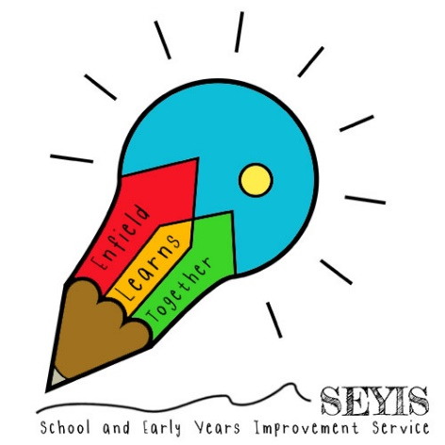

All About Me!

2020 Year 1 to Year 2 Transition Pack

Name: WRITABLE