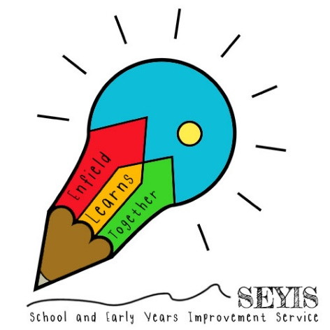
2020 Early Years Transition

Good Practice Guide

Contents
Background page 4
A suggested way forward page 4
Coming into school Nursery and Reception

Moving into Year 1 page 6
- Year R links with and ‘visits’ to the Year 1 Classroom
- A Transition Welcome Display
- All About Me! 2020 Reception to Year 1 Transition Pack
- Characteristics of effective learning in the Year 1 learning environment
- Reception to Year 1 Handover of Assessments
- Developing a Reception based curriculum and structure

Moving into Year 2 page 8

Hooked by Books by Enfield page 8
Additional points for consideration page 8

Appendices page 9
Appendix 1 – A suggested booklist for transition
Appendix 2 – A suggested transition timeline for children coming from PVIs and childminders
Appendix 3 – ‘Hooked by Books’ by Enfield
Appendix 4 – School readiness tips for parents and carers
Appendix 5 – Information on happiness/calmness boxes

Also included with this guide
- All About Me! 2020 Reception to Year 1 Transition Pack
- Additional Reception and into Year 2 pack covers
- Early Years Transition Challenge Booklet
- Starting school transition booklet (with guidance)
- Starting school transition booklet
- This is me one-page profile
- A suggested settling in plan

Please note:
This good practice guide is should be read in conjunction with the guidance for transition for SEND learners.
It is part of a suite of good practice guides which also includes:
- A good practice guide for Year 6/7 transition
- A good practice guide for young people moving from Year 11, 12 and 13

For further support or guidance please speak to your SIA or contact: eyadvisors@enfield.gov.uk

Background
In usual times, transition of children into and out of school and between key stages is a key consideration for all schools. However, in this unprecedented time, when children will have been absent from school for a number of months and had a varying degree of educational input as well as very different and sometimes difficult home experience, the issue of transition for children in early years, is even more critical. This is heightened by the Prime Minister’s decision that children in Early years, Reception and Year 1 will be returning to schools and settings from June 1st.

Change can be difficult for many children, in particular those who have additional needs. This year, however, even greater consideration will need to be given not only to what children might have learned, know and can remember but also how they feel and how they are able to process what has happened to them and others during their time away from school. Consideration will also need to be made as to how young children adapt to an entirely different school experience, in a new classroom and with a new teacher. For our youngest children, many of whom will have only distant memories of what school was like and for whom the new reality will be a strange and challenging one, how we support their wellbeing and resilience as they take these next steps, will be key to their success not just this year but in years to come.

Transition for some of these younger children will need particular attention. How these children are supported will, in some cases, be very different from their peers. Their needs and how they are met during this time will need to be discussed and agreed with the relevant teams within and between schools and, where appropriate, the LA. These will include:
- Children with additional needs including those with EHCPs
- vulnerable children (including LAC and CiN children)
- Children coming new to the LA who have been placed in a primary school, but have not yet been able to attend
To this end two working parties of primary headteachers, in conjunction with the Head of Curriculum and Standards and members of the SEYIS team have explored a number of options for children moving into school nursery, into school Reception and into Year 1. We have also considered children moving into Year 2. The outcomes from these working parties form the basis of this good practice guide. We hope you find it useful and will use the ideas and resources enclosed and attached to support some of our youngest children as they move into the next phase of their education and that it provides some simple and easy transition models for both schools and academies and their parent/carers.

A suggested way forward
Coming into School Nursery or Reception

The processes for transitioning into nursery or reception will be similar but the activities and approaches will need to be planned with the different ages in mind.

Starting Reception marks the entry point to formal education for most children and is an important milestone in our lives. Many people report much excitement as well as differing levels of anxiety for each family. Schools work hard to ensure that this
significant transition is made as smooth as possible, and this will need to be enhanced this year. Activities planned serve two main purposes, getting to know your pupils and helping them get to know the school.

It will be important to find out as much as you can about each child’s strengths, interests, experiences and difficulties so that you can prepare for welcoming them into school. This information can come from parents, previous educational or care settings or other professionals working with a child. Stay and play sessions and home visits often play a central role here, but it is very unlikely that they will be able to be implemented safely this summer. Instead consider the following:

- Create a virtual tour of the school building and grounds to include entrances that will be used and the key areas that will be used by the children such as the dining hall and outdoor play spaces
- Set up a virtual home visit via a video call. Try to include face to face communication with the child. There could be a pre-arranged activity for the child to engage in and talk with you about. You may ask them to share with you something that is important to them, and you in turn can show them something engaging in school – the small world play or home corner for example. There could be time at this meeting, or you may need to arrange another to refer parents to any documentation you have sent them about preparing children for school – school uniform, packed lunch, PE Kit etc, and to answer their questions or find out if they have any concerns.
- Create a transition booklet that includes space for a child to record something about themselves if they wish, counts down the weeks until school begins, lists ideas of things to do until then, and shows what school will be like – their classroom, coat pegs, their teachers and practitioners, the uniform, some toys, reading books for example.
- Help children to create a happiness or calmness box to bring in September, including objects/pictures that they can go to if they feel anxious or unhappy

Early Years providers also hold useful information for schools. The LA has updated its EY Transition Report to include SEND details. It is important to note, however, that a large number of settings have been closed and their staff have been furloughed so the amount of information they are able to provide this year may vary.

This year, it is very likely that there will be an increased need to communicate clearly to parents that you have planned well to keep their child safe at school and are following guidance to ensure that anxiety around the virus is kept to a minimum.

Once children are attending, it will be vital this year to think carefully about your observations of the children’s starting points as these may vary from what has been seen in previous years due to the disruption to education. The EYFS lends itself very well to holistic child development and should be used in planning. Please see ‘Settling in and Transition Plan’ and ‘Transition Timeline’.

Moving into Year 1
Transition from Reception to Year 1 is always complex, with some children who have not achieved a good level of development and some who exceed it; some who are continuing to mark make and others who can write sentences; some who will be at the beginning of their reading journey and others who are already readers. This year, it is likely that these gaps will be more evident, more pronounced and present an even greater challenge to Year 1 teachers and a more continuous provision approach to delivering the National Curriculum (see Early Excellence below ), may need to be adopted, as children will have missed a considerable amount of time in Reception and may find returning and reacclimatising more difficult. Close liaison between the Year 1 and Reception teachers will need to continue, particularly for those children found coming into and adjusting to school difficult or who were unlikely to reach GLD. Ensuring emotional wellbeing and issues around separation anxiety and attachment will need to be a focus as well as teaching core skills especially for vulnerable children and those with SEND.

In developing an approach to this transition, you might like to consider:

Year R links with and ‘visits’ to the Year 1 Classroom
If children are not yet attending school:
• A virtual tour of the Year 1 classroom and introduction to Year 1 teachers to enable children to begin to map out their new school and see their classrooms, as they will look on their return
• Video messages OR video call sent by the Year 1 teacher to the children. These video messages could include the following:
o Welcome to… Year 1, we are really looking forward to you joining us
o My name is … and I will be your new teacher.
o When I’m not in school I enjoy…
o I have seen the All About Me booklet you have filled out at home and I am really looking forward to learning more about you.
- What activities have you been doing at home every day?
These could be followed up with additional ‘updates’ from the teacher, with quizzes, challenges or ‘fun facts’.

A Transition Welcome Display
Invite children to bring in or send in via email, a photo of themselves with a caption of what they were doing in that photo during their time at home. Teachers can use this to create a welcome display that children can relate to and talk about on entry to their new class. It will also rebuild a sense of shared belonging for children. Encourage teachers to add photos of themselves too. The display can be used as a discussion point for children, teachers and parent/carers.

All About Me! 2020 Reception to Year 1 Transition Pack
Included with this pack is a Reception to Year 1 transition pack for you to use with your children. It contains a number of activities for children to do with you in school with their current teacher and at home with their parent/carers and is designed to enable teachers to see what children can do and give a starting point for conversations to help teachers to get to know the children and their experiences prior to coming into Year 1. We hope you find it useful. It can also be used for

children moving from Year 1 into Year 2 and we have attached an alternative front cover for this purpose.

Characteristics of effective learning in the Year 1 learning environment
When developing your learning environment, you may like to consider the following:
Playing and Exploring:
- Does your environment encourage children to play and explore?
- Is your learning space linked to children’s interests?
- Does the learning environment encourage independence?
- Can children self-access their own resources?
Active Learning:
- Is there time for children to show high levels of concentration without distraction?
- Have you linked your learning objectives to children’s interests?
Creating and Thinking Critically:
- Are children able to have and develop their own ideas?
- Are children in your setting able to make links between ideas, and develop strategies for doing things?

Reception to Year 1 Handover of Assessments
We recognise that assessments of what children can do will be more difficult this year. However, some, if not all of the information below, might be considered as part of handovers, with the caveat that any prior assessment data can only record where a child was when they were last assessed and that this assessment might have taken place a while ago:

Developmental level for GLD Areas: (or all 17 Areas)
- PSED
- PD
- C&L
- Mathematics
- Literacy
A comment from Reception Teacher about the child’s Characteristics of Effective Learning:
- Playing and Exploring
- Active Learning
- Creating and Thinking Critically
Phonics Group/Level

Developing a Reception based curriculum and structure
The curriculum and structure of the day for children coming into Year 1 could mirror that of Reception completely for a while and then begin to move into a more traditional Year 1 curriculum over time. It may also be necessary for some children to revisit the Reception objectives, especially for phonics, so teachers may need to be mindful of these objectives when planning responsively to the needs of individual learners so classes will need to have individual gap-filling plans for a while.

Early Excellence have been running a series of sessions for Early Years leaders and practitioners in Enfield, specifically targeted at developing effective practice in Year 1 which builds on the EYFS principles of continuous provision and how it supports the Mational Curriculum. https://earlyexcellence.com

Moving into Year 2
These children may also need extended learning opportunities with more Year 1-type activities in the initial stages, as they will have missed a considerable amount of time in Year 1 which is a crucial bridge between Reception and Year 2 and they may also find returning and reacclimatising difficult. Close liaison between the Year 1 and Year 2 teachers will need to be in place, particularly for those children who did not achieve GLD at the end of Reception and were not yet at ARE before the extended break.

The Reception to Year 1 transition pack can also be used for children moving from Year 1 into Year 2 and we have attached an alternative front cover for this purpose.

Hooked by Books by Enfield
Using Getting Hooked by Books, Hooked by Books and Still Hooked by Books by Enfield programmes to develop thinking around wellbeing, as well as instilling children’s love of reading and engagement with a variety of books and texts with the purpose of raising attainment in speaking, listening, reading and writing.

Additional points for consideration:
You could:
- Add a page on your school website specifically for transition so it becomes the ‘go to’ place for information for parents – this might contain the latest news and updates in relation to transition, along with all the information that parent/carers may need
- Establish ways that children and parent/carers can communicate with teaching staff – ways for parents to ask burning questions and share their suggestions/concerns; ways for children to share messages, activities they have been involved in at home, things they are proud of/ things that are important to them and which they want to share etc
- Consider adding an area for new children and families to your established platforms for sharing learning before they start school – e.g. Tapestry, 2Simple, ClassDojo, etc

Appendices
Appendix 1 – A suggested booklist for transition
Transition Booklist

14 Books to Help Kids Get Ready for the New School Year
https://www.readbrightly.com/books-get-kids-ready-school/

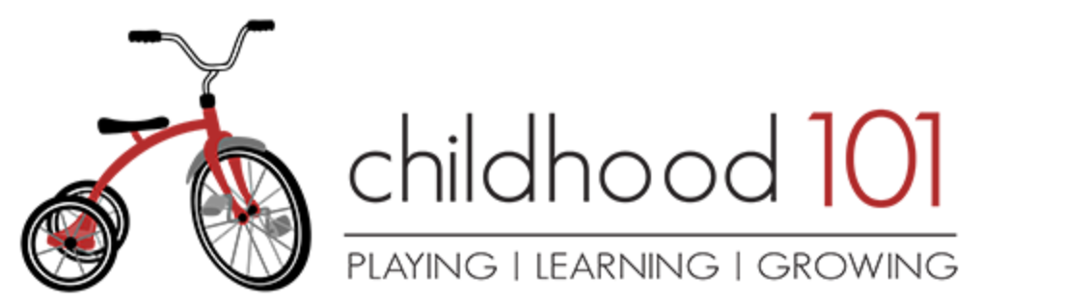 Starting School: Books to Help Ease the Transition
https://childhood101.com/starting-school-books-to-help-ease-the-transition/

Starting School
https://www.theschoolrun.com/best-books-about-starting-school

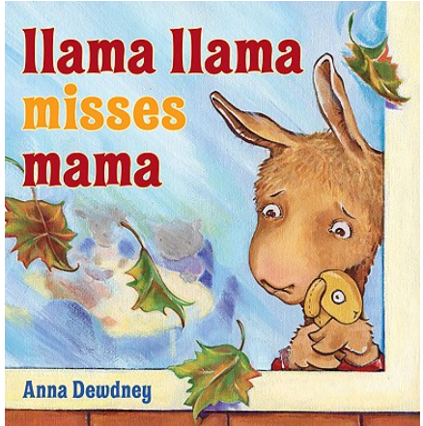 Llama Llama Misses Mama by Anna Dewdney Ages 2 to 5

This classic expertly captures the up-and-down emotions of a toddler—Yes!
Mama comes back! —making it easy for kids to connect.

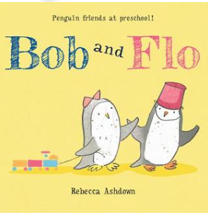 Bob and Flo by Rebecca Ashdown Ages 4 to 7
Two penguins forge a bond on the first day over a pink lunch bucket.
(Message: You’ll find a friend).

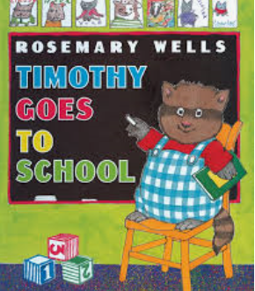 Timothy Goes to School by Rosemary Wells Ages 2 to 5
Finding a good friend can take a little time. This is a good read for kids who may
feel left out at first.

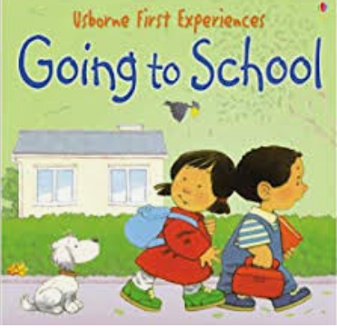 Going to School (Usborne First Experiences) by Anna Civardi

An ideal starting point for young children and adults to discuss first experiences.
Features Stephen Cartwright's delightful illustrations, providing lots to look at and talk
about.

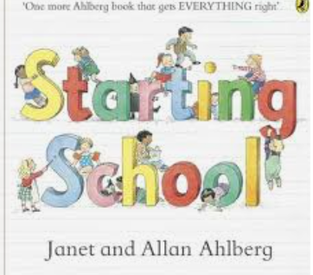 Starting School by Janet and Allan Ahlberg Age 3+

This is an enchanting picture book for reassuring children who are about to start school
for the very first time. The colourful pictures and large, simple text make Starting
School, a great book to share.

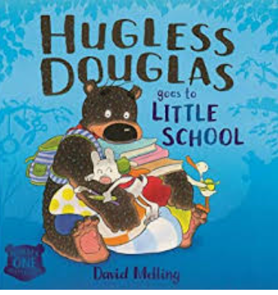 Hugless Dougless goes to little school by David Melling Age 3+

School-starters will love that cuddly Douglas is off to school just like them. Being
helpful is a good lesson to remember and it's nice to see a big character who is
celebrated for being kind and friendly instead of clumsy.

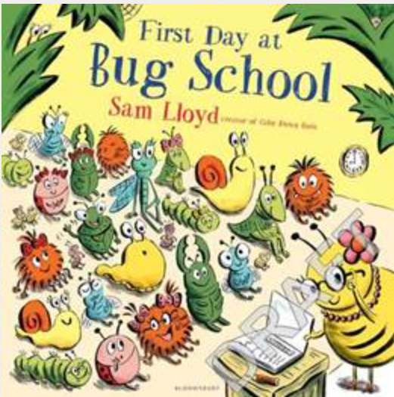 First day at Bug School by Sam Lloyd Ages 3+

Hidden at the bottom of the garden in the long grass is the Bug School. It's the first
day of term, and when the tiny school bell rings, the new pupils appear. Waving
goodbye to their parents, they enter Miss Bumblebee's classroom. She assures them
they'll have the best day ever.

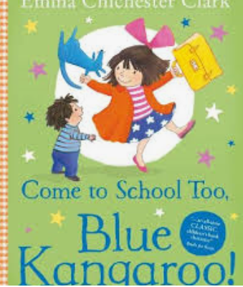 Come to School TOO BLUE KANGEROO by Emma Chichester – Clark Age 3+

Lily thinks Blue Kangaroo might be nervous about starting school – but in fact he can’t
wait to have fun and make some new friends.
Emma Chichester Clark’s warm-hearted illustrations are accompanied by a lovely
reassuring story that will help nervous children to look forward to their first day at
school.

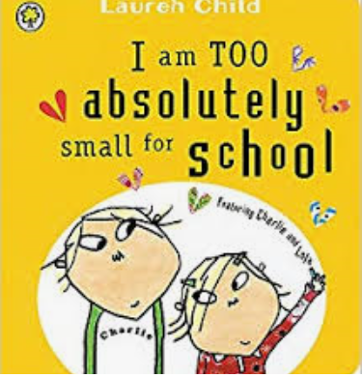 I am TOO Absolutely small for School (Charlie & Lola) By Lauren Child Age 3+

This book splendidly encapsulates the significant points in the life of a small child.
It is completely child-centred, from subject matter to illustrations, and will provide
welcome reassurance for any child who is uncertain about this big step.

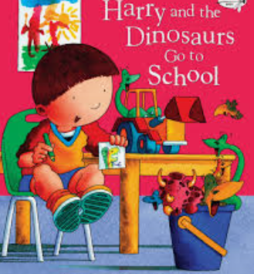 Harry and the Dinosaurs go to School by Ian Whybrow Age 4+

It's Harry's first day at school. He and his dinosaurs are very excited and perhaps a
little bit nervous. But when Harry's dinosaur friends don't join him in the classroom,
Harry's not so sure he's going to like school, but the dinosaurs come to the rescue and
Harry and his new friend learn just how much fun school can really be! This is an ideal
book to prevent first day-at-school nerves.

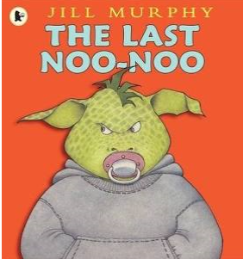 The Last Noo-Noo Book by Jill Murphy

Marlon's granny thinks it's high time Marlon gives up his pacifier. It's a noo-noo,
Marlon informs her--and he has no intention of giving it up. Nothing and no one
Can make Marlon give up his noo-noo until Marlon decides to give up his noo-
noo! With keen humour and a sure instinct for the dynamics of family life, Murphy
captures a common childhood dilemma.

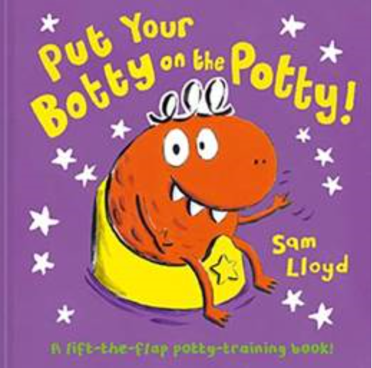 Put Your Botty on the Potty Author: Sam Lloyd
Little Moo Monster is not happy. He wants to be grown up, but he is still wearing a nappy. He decides that enough is enough - no more nappies for him! However, he needs to be potty trained quickly, so he practises sitting on it… until finally, success! Now Moo is all ready to wear grown up pants and go to the Monster Pant Party with all his potty-trained friends.

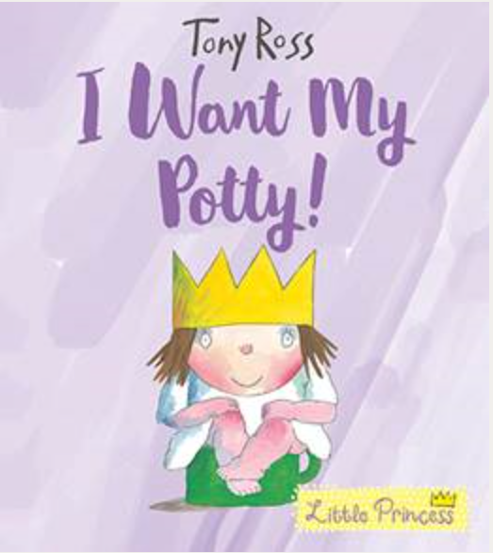 I Want My Potty! By Tony Ross
The Little Princess hates nappies and thinks there must be something better. At first she thinks the Royal potty is even worse - but she soon learns to love it, even if it isn't always there exactly when she needs it.

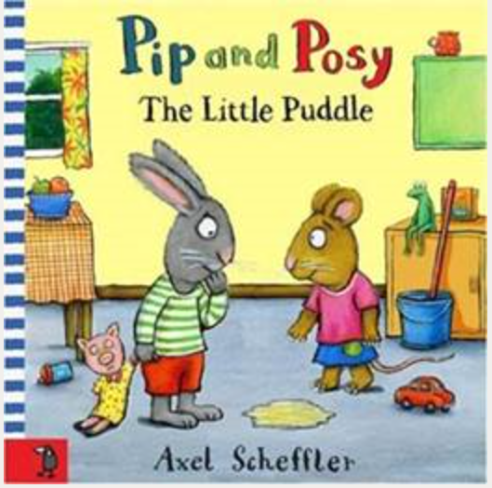 Pip and Posy: The Little Puddle Author: Axel Scheffler
Pip is having so much fun playing at Posy's house that he forgets he needs a wee and a little puddle appears on the floor. Posy takes charge and mops up the mess, telling Pip not to worry... everyone has little accidents sometimes.

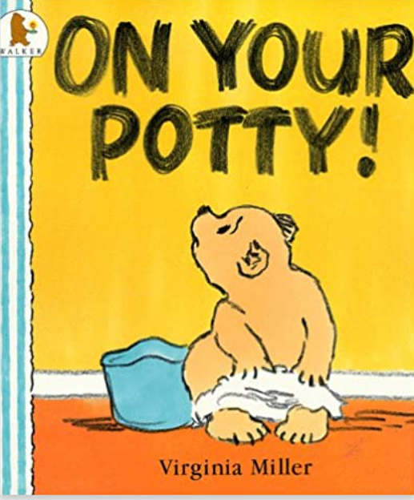 On Your Potty! (Bartholomew & George)

This is the illustrated story of a small bear called Bartholomew and how he learns to use his potty.

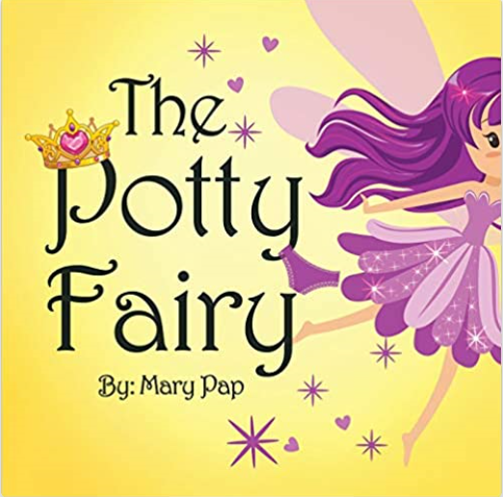 The Potty Fairy by Mary Pap

The Potty Fairy story will delight you and your child during the potty-training process. The Potty Fairy story enhances and enriches all potty-training methods and will motivate your child to use the potty chair.

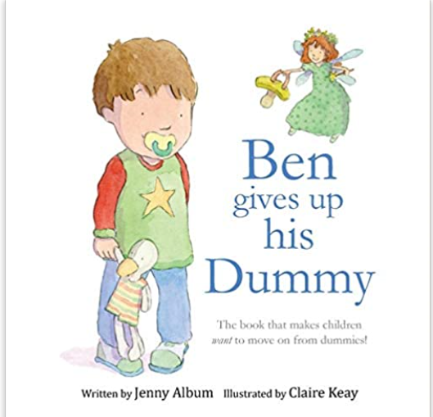 Ben Gives Up His Dummy by Jenny Album

A picture book that is designed to help children who are struggling to give up their dummies. The book follows the story of a little boy called Ben, who refuses to give up his dummy. Then one night his mother persuades him to leave all his dummies outside his room for the 'Dummy Fairy' to take - (in exchange for a special gift). The book uses a fun and imaginative story to teach children why it makes sense to give up dummies, and it also offers up some fun ideas to stop them missing them once they've gone.

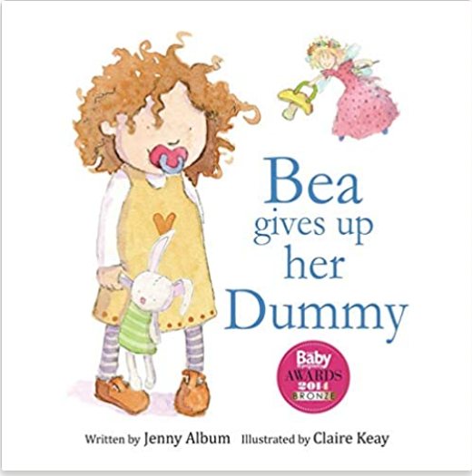 Bea Gives up her Dummy by Jenny Album
The book follows the story of a little girl called Bea, who refuses to give up her dummy. Then one night her mother persuades her to leave all her dummies outside her room for the 'Dummy Fairy' to take - (in exchange for a special gift). Bea gets to meet the fairy, who shows her that it IS possible to give up dummies without shedding a single tear.

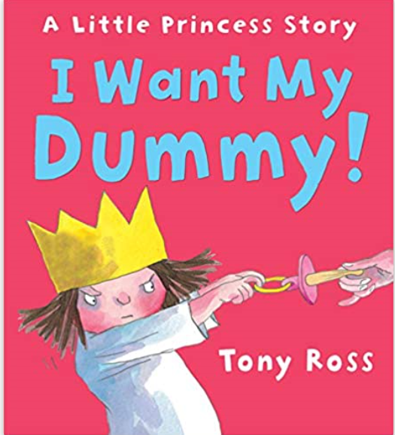 I Want My Dummy! By Tony Ross

"Where is my dummy? I WANT MY DUMMY! “shrieks the Little Princess when the royal dummy mysteriously disappears, yet again. Wherever the King, Queen and courtiers hide her dummy, she always finds it even in the strangest of places . . .
Will she ever give it up?

Appendix 2 – A suggested transition timeline for children coming from PVIs and childminders
Suggested Transition Timeline 2020

Those who are about to start school for the first time are a unique and complex group of children that will need a carefully planned transition. It is paramount that personal and social development is a priority. It has been an unprecedented time during the Covid19 lockdown and the impact on families with young children will be vast and complex.

The DFE Early Years Good Practice Guide Research Project highlighted 3 broad areas for a successful transition
- Gathering information about the child
- Working in partnership with the other setting/s
- Providing information and support to parents and carers

- The key factors in supporting a good transition to school are;
- A commitment from all professionals to support every child fully with a shared and consistent approach
- A commitment to develop clear communication links
- Continuity of support for children transferring from a provider and/or childminder
- Working in partnership with parents

Issues to consider:

- Socially Isolated
- Highly stressful home situation including fears
- Possible loss of family members and dealing with grief
- Increased in domestic violence in some households
- Poverty, hunger, and deprivation
- No physical contact with extended family
- Lack of opportunities for play and physical activities
- Limited access to outside open spaces and nature
- No playing with friends or other children
- Home learning will be diverse and sporadic
- Emotional and behaviour difficulties
- Expectation for learning routines will differ greatly

Transition and information gathering between the child family, providers and/or childminders, and any other professionals involved in working with the child is an essential element of an effective transition. Schools should establish a clear understanding of one another’s aims, purpose and philosophy.
Summer | Spring | Autumn
Summer 1  May-June  Summer 2  June-July | Spring 1  January-February  Spring 2  March-April | Autumn 1  September-October  Autumn 2  November-December
Communication with provision/school to alleviates any fears and prepares the children for where they are going to be going next.  Complete transition pack with parent/s.  Induction communication arranged with parents/carers and/or with practitioner (Provision/Childminder)  Early Years summary/transfer report sent to provision/school.  Visits to new setting/ school to alleviates any fears.  Photo book/Poster or power point about the new setting/school include a video tour  Photos of key staff  Information received from provision – Transition report  Stories about starting school, transition, fears and worries (see book list)  Review:  Transition policy  Settling in policy | Communication with parents regarding school admissions application process  Deadline- January for reception age children  Transitions meetings to be arranged and plan meetings  Transition meetings arrange and planned for children with SEN&D. | Evaluate transition process:  Sharing of information  Continue to develop and build close links with main feeder providers/childminders

Appendix 3 – Enfield ‘Hooked’ Reading Programme 2020-21

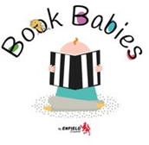
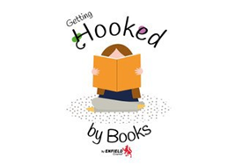
Year 1 and 2
Reception
Nursery – 2-4yrs
Nursery -Birth to 2yrs yrsyears
Course content
- Choosing and using high quality books with themes that tap into children’s interests and concerns

- Making opportunities for children to talk about books and texts, characters and plots

- Using a different approach for using books that has cross-curricular links and particularly promotes communication and language development

- Understanding how this approach supports the themes of the new Ofsted inspection framework for early years in both schools and PVI settings

Appendix 4 – School readiness tips for parents and carers
Due to the disruption to childcare and education we have seen recently, parents have been asking for some tips to prepare their child for starting school this year.

Please be assured that staff in school are very experienced in enabling children develop at their own pace and will be on hand to help your child at school.

The following tips will help your child become more independent. Have fun with them!

- Play games to encourage turn-taking, waiting, sharing and coping if you lose a game. Board games, card games and sorting games are good for this and will also develop language.
- Sing songs and nursery rhymes together. Share a book together, let your child retell parts, turn the pages and talk about the pictures.
- Walk like an animal – elephant, penguin, frog etc. Use different surfaces, steps or slopes. Walk as much as you can, avoid using the buggy where possible to build strength, balance and stamina.
- Strengthen little hands by squeezing sponges, painting and drawing, fastening containers, using pegs. Play with dough, help with cooking and gardening where safe, fold the laundry.
- Help them become independent when dressing – show them what to do, ask them to copy. Let them do a bit more each time.
- Help your child become familiar with their lunch or snack box if they have one, be able to open or close it, be able to use cutlery and drink from an open cup as well as they can. Eating at a table can be unusual for some so it is worth letting them experience this too.
- Encourage independent toileting, working at the child’s individual level and at their pace.
- Practise putting on and taking off their school uniform. Don’t forget the shoes, socks and buttons! Piling up clothes in one place will help avoid losing anything.
- Practise the route to school. Talk about what the routine will be, for example get ready for school, walk to school together, say goodbye to mummy/daddy/carer, play and learn at school, home-time, walk back home, etc. Remember to tell them what you will be doing whilst the child is at school, and that you will see each other again after school.
- Give your child a photo or memento of home so that they feel connected to their most familiar environment and will be reminded that you will be reunited soon.
- If your child has a comforter such as a dummy, blanket or bear get them used to putting it in their bag when they are not using it. This is a good way for them to independently know where it is and how they can access it if they need it.

The National Literacy Trust has some excellent ideas for developing speaking and listening skills at: https://cdn.literacytrust.org.uk/media/documents/At_home_booklet_for_parents_final_digital.pdf

Appendix 5 – Information on happiness/calmness boxes
A happiness or calmness box is a small, discreet box containing items that soothe a child who is experiencing elevated anxiety levels. It may contain objects, or activity cards that help the child regulate their emotions. The items should mean something to the child. Each activity should be short and can be carried out independently or with a key adult if available. The box may contain a photo of someone from home, a feather, aroma dough, paper clips to link together, yoga stretches, breathing exercises, fidget toys, visualisation exercise, sorting activity.

For more reading on happiness/calmness boxes see Louise Michelle Bomber’s book Inside I’m Hurting and for more information please contact Julia Hide (Julia.hide@enfield.gov.uk)

