I’m getting ready for school,
and school are getting ready for me.

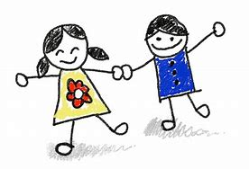

Child’s name:
Early Years Setting name:
School name:

Transition Plan
Things my school need to know going back after lockdown
How I feel about returning to school with all my peers? What am I worried about?

Professionals working with me – Who is working with me now? Who will still be working with me when I start back at school? Who used to be working with me?

Do I have any health needs? – Do I have any diagnosed health needs, allergies, dietary needs, regular medication, health care plans, moving and handling plans, emergency protocols? Also including risk assessments and behaviour support/management plans.

Do I have any family/home needs? – Is there anything happening at home that you need to know about that happened during lockdown?

What helps me learn? – Any resources or equipment in place to help me learn? (including use of visuals, Makaton signs), specialist equipment or environmental changes required (seating position, furniture location etc)

What helps me to have a good day? – Are there any parts of my daily routine that I find particularly difficult to manage and that are affected by the new Covid 19 rules?

What things can I do for myself, and what things do I still need help with?(including dressing/undressing, using the toilet, completing personal care tasks, eating and drinking etc) – How these may be different because of Covid 19 rules.

What and who is important to me?

What I am worried about?

Covid 19 transition book completed by:
Date:

