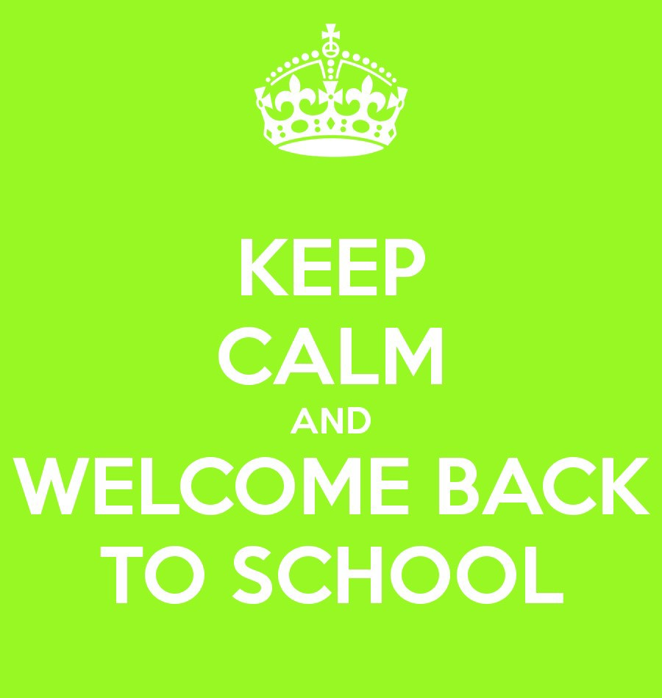

Pupil’s Name

Date of Birth

Year

School

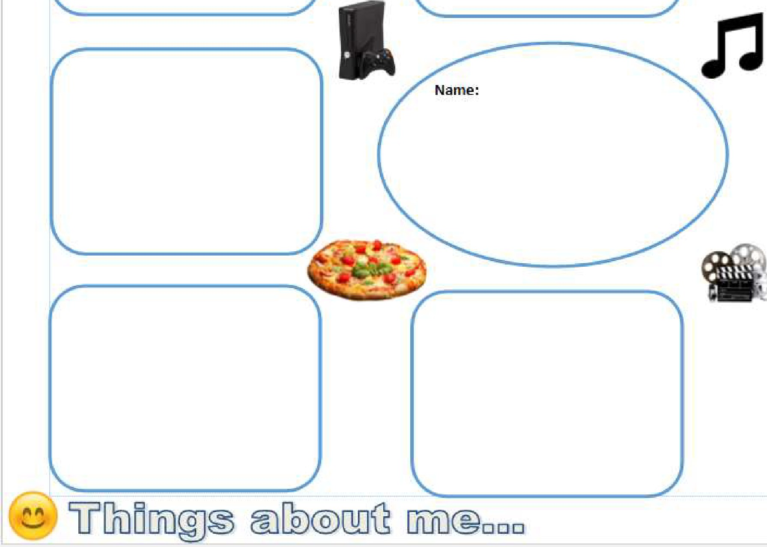_.,---- - - - - - - - - --
--- --- - -
In each of the boxes, put a fact
about yourself.
It oould be favourite things, stuff you like to do or even things you really don't like.
You ran draw pictures or writ e one word or a sentenoe.
this is about you, so there is no right or wrong:)

- - - - - - - - - - - - -=---- -

Staying at home Time on your own
Lonely
Unsafe

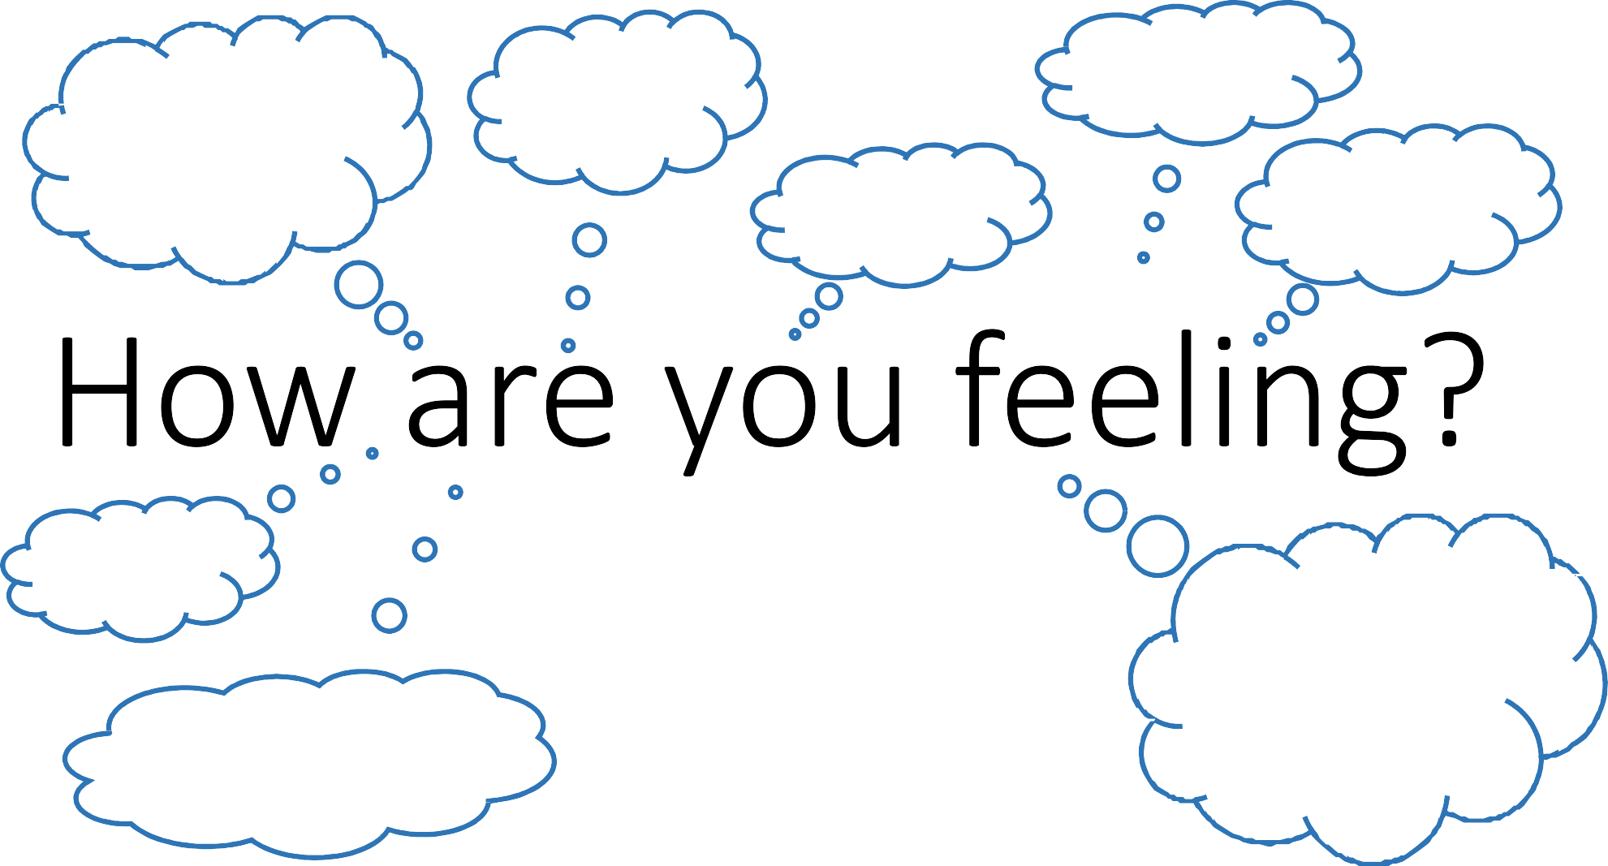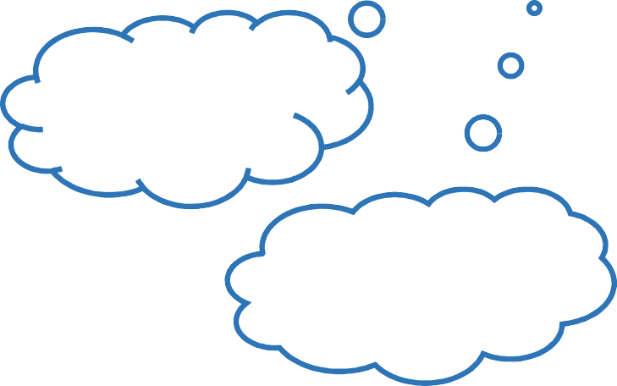Scared Anxious

Happy

Overwhelmed
Isolated

Worried

Not seeing friends Not seeing family Keeping in touch

Back to school after lockdown How do I feel?
- Since schools closed in March, our lives have changed in many ways.
- Some of these changes may have been difficult, for example, not seeing our friends, while others may have been more positive: no weekend homework, pressure about exams and no getting up early on a Monday morning!
- Now that schools are planning to invite all students back, you may experience lots of mixed feelings: excitement, anxiety, relief, fear, anger, which may be difficult to cope with.
- One way to share your feelings with those who may be able to help, and to find ways to make things better, is to use ‘scales’ and numbers, to ‘score’ your emotions.
- Have a go at completing the scales. As you do, try to think of ways to move up the scales. Just half a point is fine to begin with and there are bound to be ‘blips’ when you feel yourself going down the scale.
- Make sure you share your scales with those around you that you can trust and feel safe with and who might be able to help you to think of strategies and ways forward.

SCALES

1.

0 2 4 5 6 7 8 10

lto ts o f w o rr i es Now.oll'l!'ies:

My feefings about going to school before lockdown

My feelings about going to school after lockdown

2.

0 2 3 4 5 6 7 8

My feelings about leaving my Parent/carer before lockdown

My feelings about leaving my Parent/carer.- after lockdown

3.

0 ii 2 4 5 6 7 8 9 10
My feelings about seeing my friends before lockdown
My feelings about seeing my friends after lockdown
4.

0 2 4 5 6 7 8 9 10

My feelings about seeing teachers,before lockdown

My feelings about seeing teachers after lookdown

DQ: Can I learn about protective behaviours to keep myself and others safe?

What are Protective Behaviours?
- Protective Behaviours, or ‘PBs’, is a framework for personal safety. It will help us keep safe by talking about daily life, real situations, having adventures and taking risks.
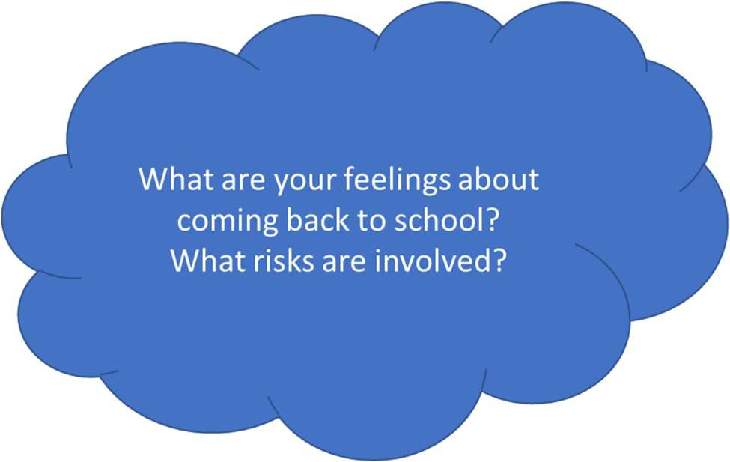

A big risk for all of us is coming back to school after lockdown. Why?

Problem Solving Mind M lap

  - 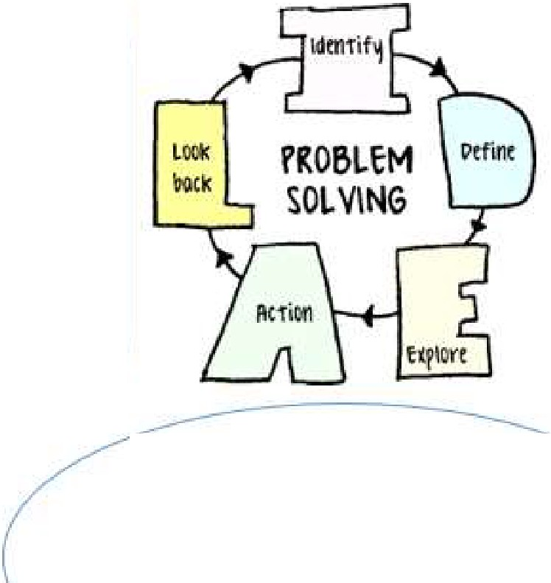What, possible reasons are there for this?
2.what do I know about the problem?
1.What is it?

3.What dont I know?

  - What are the possible solutions?

Circle which solution you are going to try.

Transitioning Back to School

....
•
,
 |  |  |  | , | _ ,.,?-;
 |  |  |  |  | .-,r/1\.... |  | q_
 |  |  |  |  | ]ntensi t y | How | I Fe e l
 |  | - us
vaccine
1£.-.,....-....
Social distancing
Wearing | a mask |  | in shops
i -_-,,»,,-·
Is o l a t e d
washing hands
i
coughing

Vir

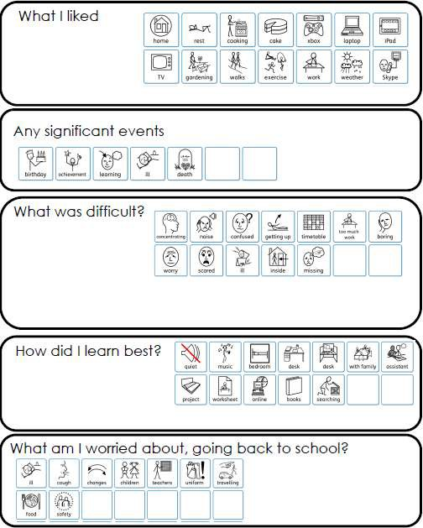
My Lockdown Experience

We all have the right to feel safe all of the time.

With that right comes a responsibility not to do anything that would leave other people feeling unsafe and we can identify if we are feeling unsafe.
How do we do this?
We need to tune into our early warning signs, those things that happen in our body like butterflies in the stomach, wobbly knees etc.
Can you think of any more early warning signs?

If we don’t feel OK in this particular situation and we get those ‘Early Warning Signs’, PBs encourages us to think clearly and work out what we should do.
We all need a support network
We can talk with someone about anything, even if it feels awful or small.
Think of 5 people who can help us solve problems. They might be:
- people who ask questions so that we can come up with our own solutions;
- people who actually give some advice;
- friends or family
- people at the end of a phone help line - sometimes it’s easier to phone a help line as we can remain anonymous.
Having four people plus the ones at home is a good idea so that we have a back up plan if our first choice of contact is unavailable.

Why do we have to be careful about people we don’t know at the end of a phone line or on a website?
Kooth.com Your online mental wellbeing community: Free, safe and anonymous support

Feelings, thoughts and behaviour

Learning objectives: To learn and understand that:
- everyone has feelings.
- we experience different feelings at different times.
- there is no right or wrong way to feel.
- we may mask or hide certain feelings with other feelings.

Resilience
- Being able to offer others support is kind and of huge value (in learning and for life).
- Being able to ask for support in the right way is really important (in learning and for life).
- It is ok to feel big feelings from time to time and to experience discomfort with these feelings.
Big feelings will usually pass, and it is a great idea to ask someone for help at such times. Other people will usually want to help where they can.

Discussion

Does everyone have feelings?
How many different feelings can we have?
  - Do we all feel the same feeling at the same times?
Task: Imagine you are walking down a path and you find a big blue box … what do you feel as you remove the lid?
  - Having lots of feelings is not bad
  - It’s not ‘bad’ being angry, it’s what actions you take when you are angry that might cause us difficulty, not actually having the feeling.

How do we show our feelings?
How do we know what others are feeling?

    - expression/face
    - body language and behaviour
    - with our voices
    - Insert video clips here

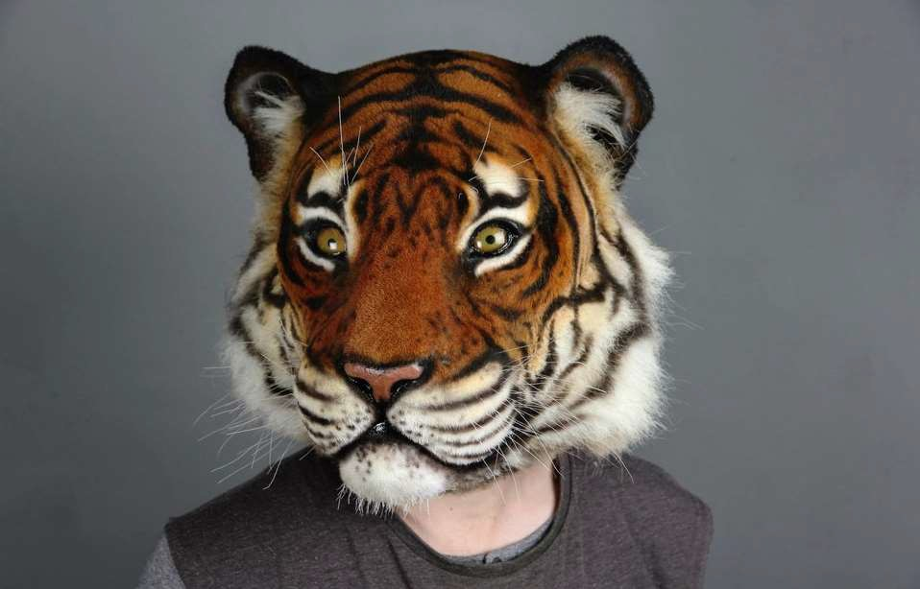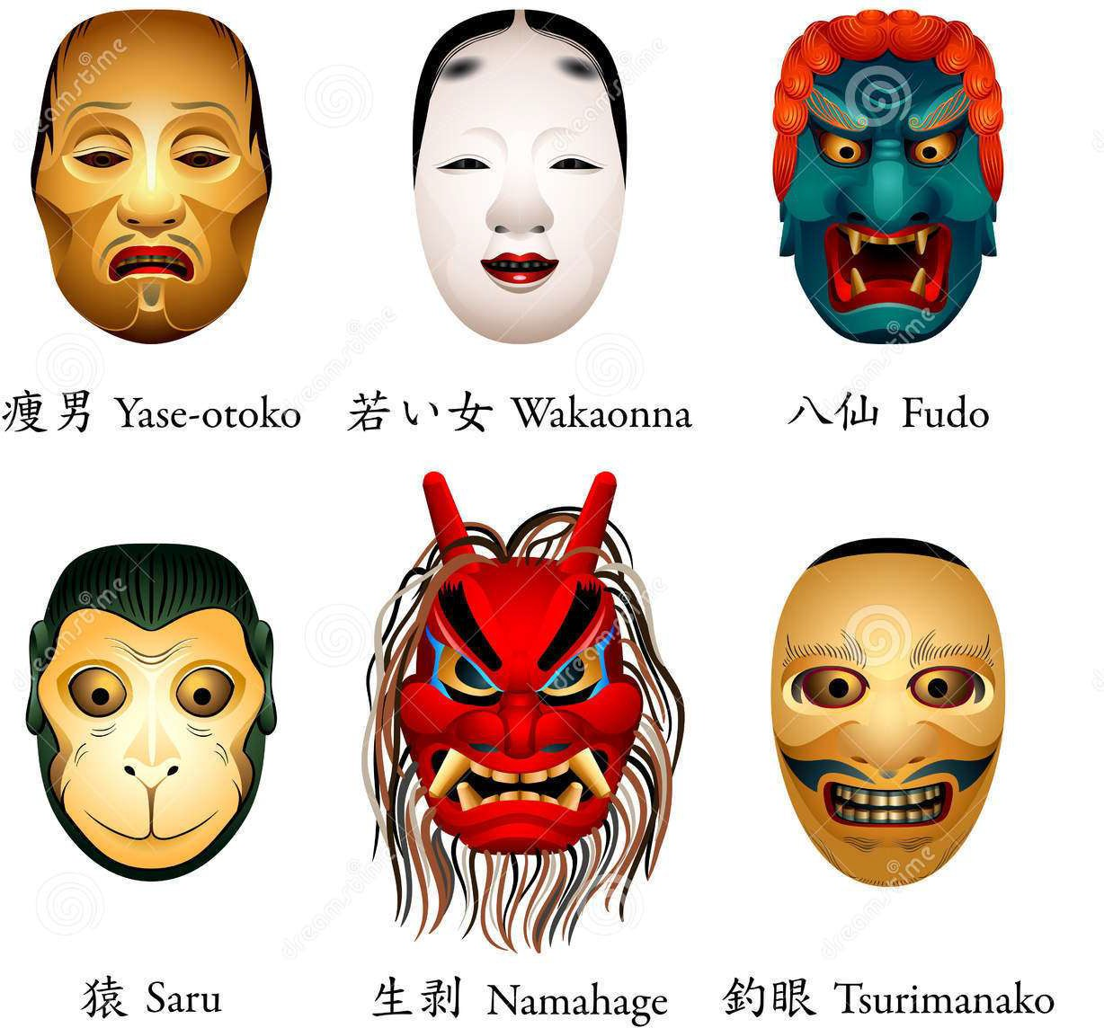
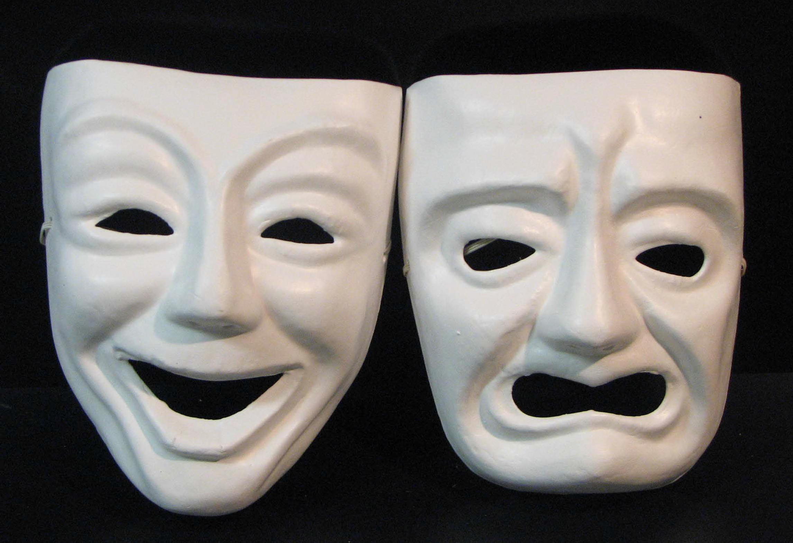

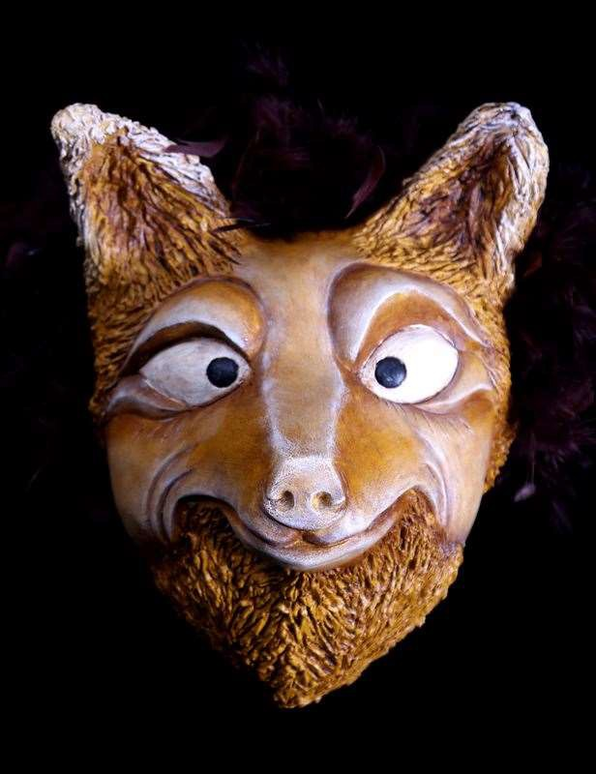

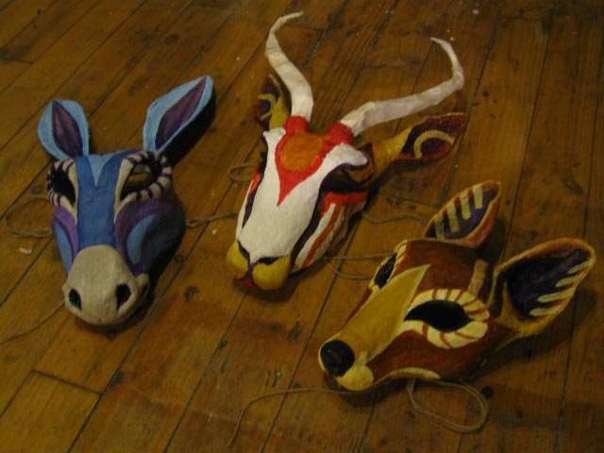

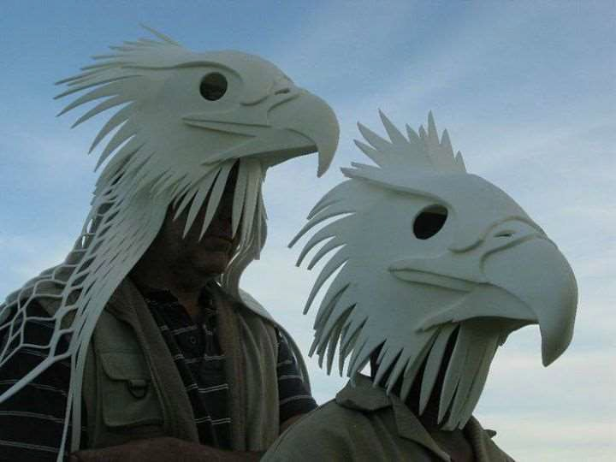

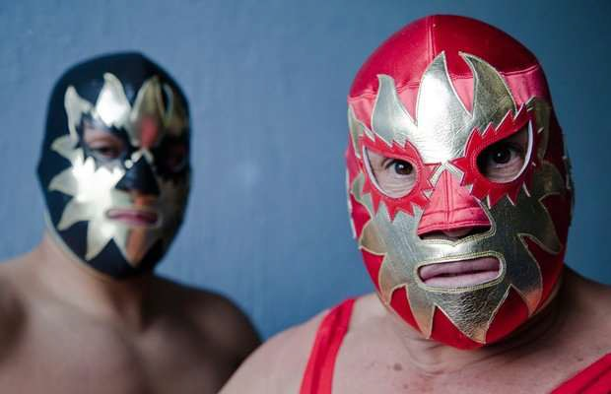

Why do people wear masks?
Why might somebody choose to wear a tiger mask?
Which masks do you associate with feeling powerful or hiding?
Masks

What are masked feelings ?
Sometimes we hide the way we feel inside and use our faces, bodies and voices to mask the way we feel.
One day I felt really sad because I couldn’t find my favourite pen when I arrived at school. I spent all day feeling sad because I missed my pen but instead of showing the way I felt, I pretended that I was fine and happy by smiling and sounding cheerful. I hid behind a mask.
- Why did I feel I needed to do this?
- How did I feel when I got home? Why?
- Where is my pen now? Why didn’t I ask anyone to help me look for it?
- What advice would any of my 5 key people give me for next time?
- When is it the right time to mask your feelings?
Sometimes it’s good to show your feelings as long as you do it in a way that keeps you and others safe.

