Covid-19 Support Page

Please find below a list of organisations that are available to support parents, carers and young people with a range of additional needs including; SEND, brain injury, Autism, and physical disabilities.

List of support services (National): <https://www.kids.org.uk/national-organisations>

London Special Educational Needs Information and Support Service (SENDIASS): <https://www.kids.org.uk/Pages/Site/sendiass/Category/london-sendiass>

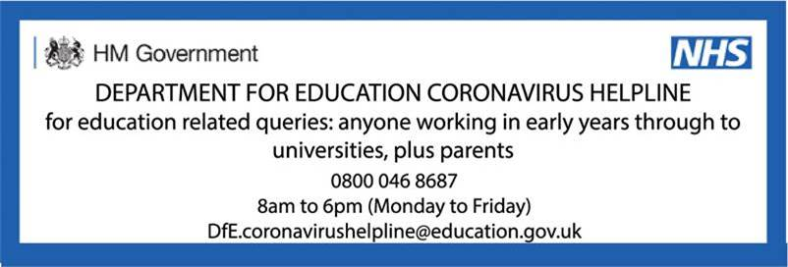

Please see below for the current (23/03/2020) guidance on vulnerable children and young people:

<https://www.gov.uk/government/publications/coronavirus-covid-19-guidance-on-vulnerable-children-and-young-people/coronavirus-covid-19-guidance-on-vulnerable-children-and-young-people>

Enfield Council support:

Enfield Council and Enfield Voluntary action have bought together key local partners and organisations so that we have a coordinated effort across the borough to organise volunteers and reach those who need help. Please follow the link below to find forms for if you **want to help**, and if you **need help**. <https://new.enfield.gov.uk/services/your-council/enfield-stands-together/>

Prevent support and Covid-19:

As the picture changes day-to-day, we need to gain an idea of how to best support educational establishments at this difficult time. Please get in touch with the Prevent Education Officer, Evie if:

* It would be helpful for us to know if your school is closing completely.
* You have a new or ongoing safeguarding concern linked to radicalisation/ extremism
* You have a safeguarding concern and don’t know where to access support

Please use the following contact details:

Phone: 02081484352

Mobile: 07866153709

Email: [evie.gibson@enfield.gov.uk](mailto:evie.gibson@enfield.gov.uk)

We hope to send out as many resources as we can to help facilitate at-home learning, and also for those children still attending school. If there are any resources you want to see from us specifically, please do get in touch with Evie.

It is especially important to monitor online useage and materials access online. Please ensure that parents and carers are aware of how to access suitable and accredited materials, if they are not using those provided by your establishment.