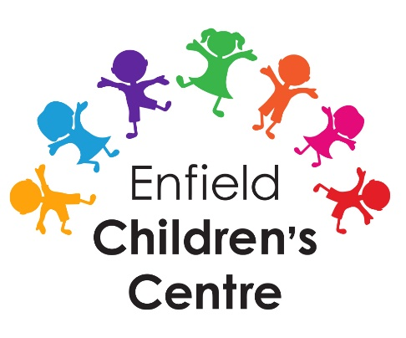
New Baby On-line Group

Enfield Children Centre is running an on-line information course for all parents who have a baby aged 2-4 months
The aim of the course is to provide parents with support and information available in the borough.
The sessions will be run on a Tuesday from 1pm to 2pm by a range of professionals covering the following topics:
Infant Feeding
Parents’ well-being
Sleep and Well-being
Childhood illnesses
Early Communication & Play
For more information or to book a place, please contact Natalie Lewis on 07719324756 or alternatively contact the Children Centre on
020 8106 9996

