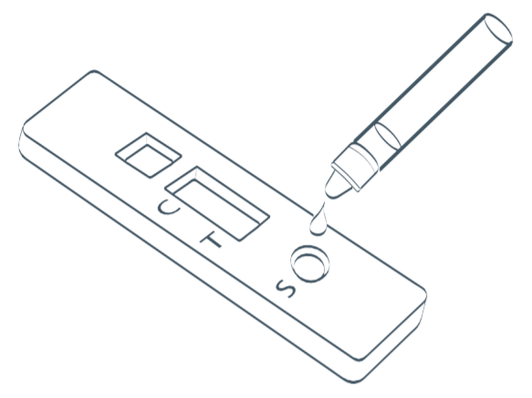

Attigo Academy Trust
Staff Rapid COVID-19
Lateral Flow Device (LFD) Test

Contents

Information
There are two types of COVID-19 tests:
LFD Test  (Lateral Flow Device) | PCR Test  (Polymerase Chain Reaction)
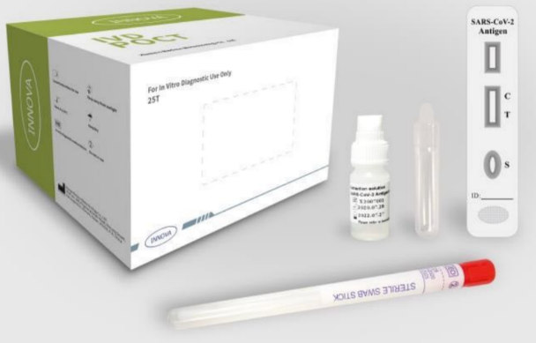 | 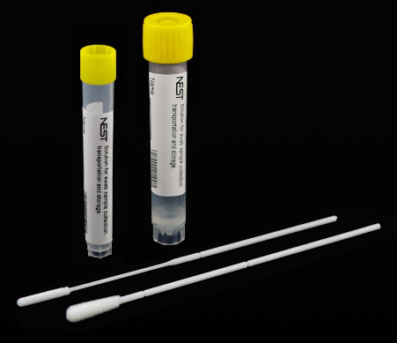
Following the launch of rapid asymptomatic coronavirus (COVID-19) testing in secondary schools and colleges on 4 January, staff in primary, school-based nurseries and maintained nursery schools are also being offered the opportunity to take part in regular asymptomatic testing. Approximately 1 in 3 individuals are asymptomatic when they contract COVID-19 and it is believed that the use of regular LFD tests amongst staff will help to identify those who may be positive for COVID-19 and are still infectious yet are asymptomatic. Initially these tests are only for those staff working in school.
If you are currently working from home you can still have a weekly test as we have secured slots for each school which are listed below:
- Alma: John Wilkes Tuesday 4pm
- Houndsfield: John Wilkes Monday 4pm
- Keys Meadow: Kempe Hall Tuesday 4pm
- Worcesters Brigadier Hall Tuesday and Thursday 4pm

Opting in/out
Testing is not mandatory for staff and staff do not need to provide proof of a negative test result to attend school or nursery in person, although participation in testing is strongly encouraged and will help to keep infection rates down. Further information about opting in is on page 4.

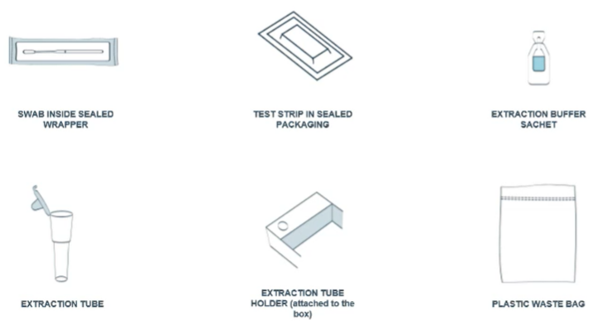
Kit Contents
Your kit should contain the following items:

Instructions
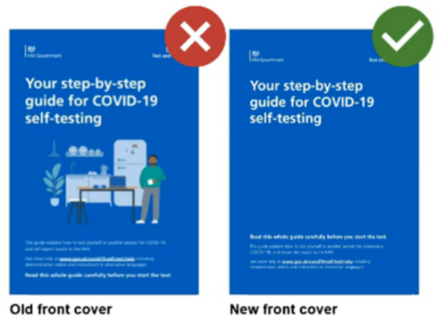
Full instructions on how to administer the LFD tests are given alongside your test kit. Inside your testing kit is an old set of instructions which should not be used. Please recycle the old instructions and follow the new set of instructions.
Each test takes approximately 5 minutes to administer and 30 minutes for a result to show. Please read the instructions carefully.
Staff are required to take their LFD test at home after school on a Monday and a Thursday, before 7pm. However, if this is not feasible, you can administer them on a Tuesday and Friday morning. The rationale for the Monday and Thursday evening is this will allow enough time to arrange cover if appropriate. All staff are required to complete and submit a form to inform senior staff of the test result.

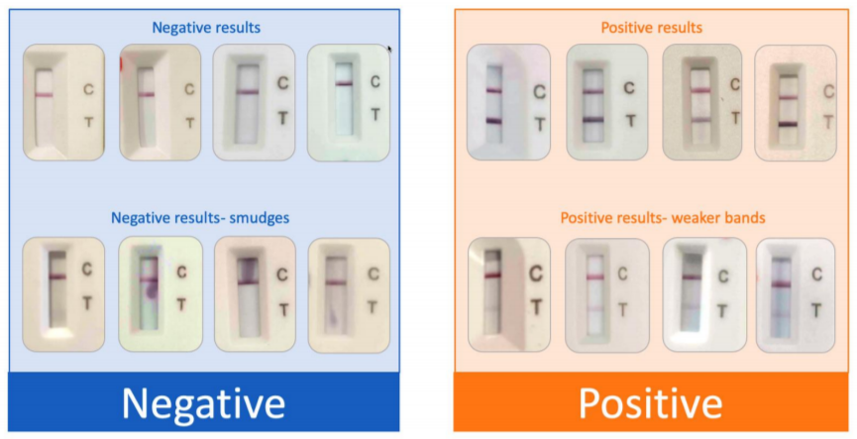
Results
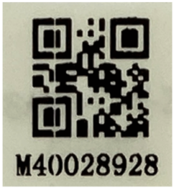

(Example Test ID)

If the LFD test shows negative
If the LFD test is negative, staff can come in to school as normal. Staff must report their result to NHS Test and Trace as soon as the test is completed either online or by telephone as per the instructions in the home test kit. Staff should also share their result with their school as we cannot view the portal on the NHS Track and Trace. Please use the ??????? to inform the school of your result.

You must let the school know if you have been unable to take your test for any reason. You can dispose of your test in the waste bag and your normal household waste.

If the LFD test shows positive
- Stay calm! A positive LFD test may not necessarily mean you are positive for COVID-19. You must inform school by contacting the ?????????????? immediately.
- You must begin your self-isolation and arrange a PCR test at your nearest test centre. You must inform the school when the test is booked.
- If a member of staff tests positive then the bubble and other contacts will be asked to self-isolate until a PCR test result is received
- Staff must report their result to NHS Test and Trace as soon as the test is completed either online or by telephone as per the instructions in the home test kit.

If the LFD test has one ‘void’
You must use one of the other test kits to repeat the test. If the test works the second time round, please follow the instructions above for either a positive/negative test result. You must also inform the school of a void test as we may need to report faulty tests to the DFE.
If the LFD test shows two ‘voids’
This is very uncommon. In the event of two voids, you will need to organise a PCR test. Please see step 1-4 of the positive test steps.
For those opting in
If you have completed the online form and opted in by Friday 22nd January, you will be able to pick up your testing kit on Monday 25th January from the school hall. If you do not work on a Monday, your kit will be kept in the main office for when you are next in. The kits will be labelled with your name and it is essential that you pick up your test and the new set of instructions. You will also need to sign for your tests; in order to reduce the risk of transmission, please bring your own pen. Please remember to socially distance whilst waiting to collect your testing kit.
Initially these tests as stated above will only be for staff working in school. This will include any staff who are regularly on site and work with children or staff in the school eg music specialists, drama teacher, sports coach, agency staff etc
FAQs
Should I use the LFD test if I have started to develop COVID-19 symptoms?
No, the LFD test should only be used if you are asymptomatic. If you have developed COVID-19 symptoms, you must self-isolate immediately and organise a PCR test. You must also inform the school that you are booking a test.
Should staff members continue testing if they have already contracted COVID-or if they have received the vaccine?
Yes, staff can still be involved as this helps to understand the effects of the vaccine and to also identify if individuals can test positive for COVID-19 more than once.
Can I give one of the LFD tests to another household member?
No, the LFD tests must only be used by the named staff member. Other household members should access PCR tests in the normal way if they are symptomatic.
Does a negative test result mean I can stop my isolation period early if I previously tested positive and it hasn’t been ten full days?
No, government self-isolation advice should be followed at all times. This test does not remove the need to self-isolate.
Do the tests need to be stored in certain conditions?
Tests can be stored in normal household conditions (between 2°C and 30°C). They do not need refrigeration but should be kept out of direct sunlight and not be exposed to heat.

The LFD home-test kits for use by primary school staff are not being recommended as an alternative to self-isolation. If a member of staff has been in close contact with the confirmed case of Covid-19, they should follow the guidance and self-isolate.

Questions
If you have any specific questions, you can ?????????????????????
Quick Links
Step by step guide to COVID-19 self-testing
(This is the NHS version but will be updated when the education version is released – the test administration is the same but the reporting is different)
To book a PCR test

