Summer Newsletter 2021 – Supplementary

Oak Processionary Moth
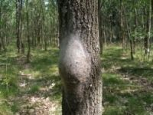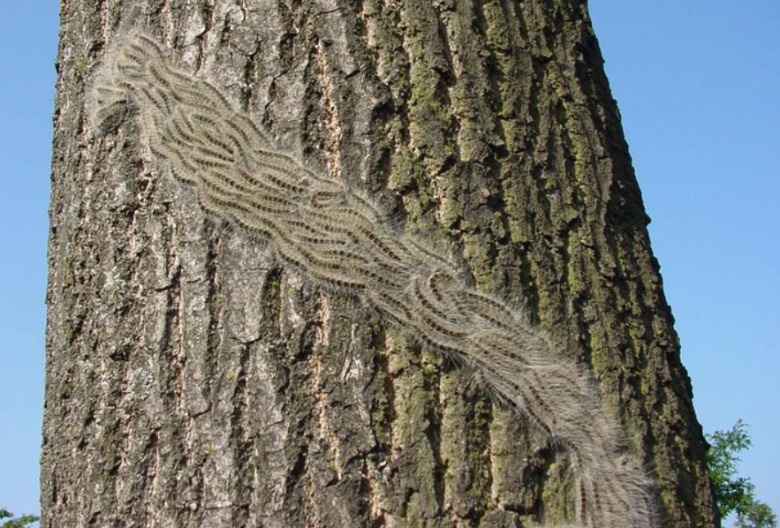
The Oak Processionary Moth (Thaumetopoea processionea) is a pest that lives on oak trees and poses a risk to human and animal health. Contact with the hairs can cause itching skin rashes (picture below) and eye irritations, as well as sore throats and breathing difficulties in people and animals. The risk of exposure to these hairs is highest in May and June.
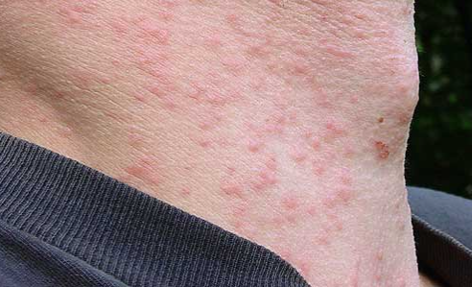
Currently we are aware of a tree in an Enfield School that has been affected by The Oak Tree Processionary Moth. This is currently being looked at by the Forestry Commission along with the Arboriculture Team based at Enfield Council.
Please note: The Landowner (the School) is responsible for dealing with this pest and all sightings should be reported to the Forestry Commission (please see attached form.
Please do not touch the larvae or caterpillars or disturb any nests and teach children not to touch or approach any nests or caterpillars. You should not tread on the caterpillars as this will detach the hairs that cause the health problems. Animals are also affected, and they must be kept away from the nests and caterpillars.

Health advice
If you do come into contact with the larvae or caterpillars, please follow the health advice about dealing with caterpillar hairs on the NHS website. If you have an itching skin rash and/or conjunctivitis or other symptoms, contact your GP, or call NHS Direct on 111. The call is free from any phone.
There is more information about health precautions on the following link Forestry Commission website and if you have any queries regarding this, please contact TreeGroupMailBox@Enfield.gov.uk. For all other queries please refer to the Enfield Council tree web page. Please click HERE.

Also attached is some information from the Arboriculture Team.

Cutting back trees

We have also been advised by some of our schools that contractors have been providing large quotes for cutting back trees. Just a reminder to you all, that the Enfield Arboriculture Team also provide this service and have a very experienced team. Please contact Andy Robinson (Principal Arboricultural Officer) andy.robinson@enfield.gov.uk.

