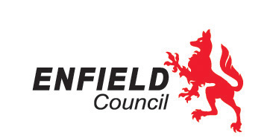
 | Please reply to: | Debbie-Ann.Ofosuware@enfield.gov.uk
 | E-mail: | Debbie-Ann.Ofosuware@enfield.gov.uk
 | Phone: | 02045265183
 | Date: | 10/09/2021
Dear Headteacher,

Youth Alive Programme

The Youth Alive programme is due to be launched on the 7th October 2021 for children and young people aged 10-19 who live or study anywhere in Enfield. It encourages children and young people to look after their wellbeing, build their confidence and happiness, feel empowered, learn a new skill and take part in physical activities.

The aim of the programme is to improve health and wellbeing of Children and Young People in a community setting. The programme encourages Children and Young people to take part in activities such as basketball, football, cooking, acting and drama lessons. All activities will always be conducted in line with Public Health England Guidance on coronavirus infection, prevention and control.

Children and Young people will be referred to their local Health and Wellbeing Youth Worker, who will discuss what the child’s/young person’s interests is and signpost them to free or low-cost activities. To refer, you can complete a referral form, which is attached to this letter, and email this to a link worker, (socialprescribing@enfieldva.org.uk), or by phone, 02083736268. Following this referral process, a young person will be contacted by a specialist Health and Wellbeing Youth Worker.

We will be sending a banner with details on the Youth Alive Programme and we kindly request that this be displayed outside of your school to raise awareness of the programme.

Yours Sincerely,

IMPORTANT – Are you Registered to Vote? Do you want to vote by post? Apply early.
To find out more go to www.gov.uk/register-to-vote

