Pre-election period (purdah) guidance for the local government elections on Thursday 5 May 2022

Pre-election period: 00:01 on Wednesday 23 March 2022 to 10:00pm on Thursday 5 May 2022.
The local government election for the London Borough of Enfield will take place on Thursday 5 May 2022.
The sensitive pre-election period will commence on Wednesday 23 March 2022 when notice of the election is given and will end at 10:00pm on Thursday 5 May 2022, when the polls close.
Adherence to the pre-election period principles will ensure that democratic due process can be facilitated and standards of good governance maintained whilst reducing the risk of members or officers being challenged in respect of possible breaches of the rules.
This document sets out guidance in relation to protocols to be followed with regard to:
- Publicity;
- Events;
- The attendance of officers and councillors at Council arranged meetings;
- The use of Council and community buildings by candidates/political parties; and
- Visits to schools by candidates and others directly involved in the elections.
Please ensure this guidance is cascaded to your senior managers so they can ensure compliance within their areas of responsibility
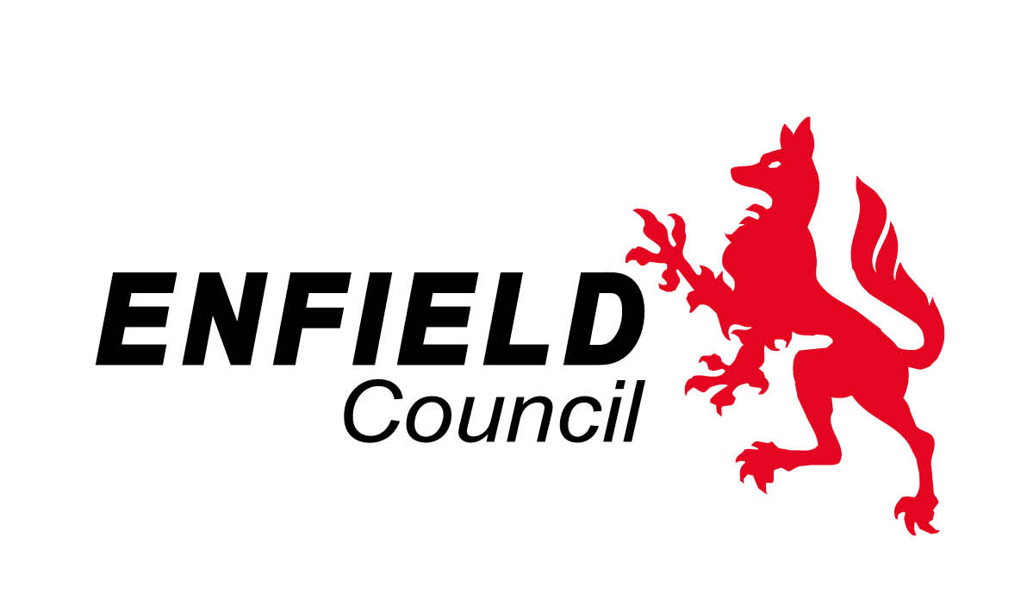

General Information
As part of established day to day practice, the Council, its members and officers should be aware of the special rules designed to ensure the political impartiality of all Council publicity. It is important to note that it is unlawful for the Council to spend money or provide resources to assist with anything designed to affect support for a political party. This rule applies at all times but it is particularly important in the sensitive pre-election period (commonly known as ‘purdah’) which starts from the date of the notice of election. In respect of the forthcoming local election in Enfield, this date is 23 March.
Section 6 of the Local Government Act 1986 defines publicity very widely as “any communication, in whatever form, addressed to the public at large or to a section of the public”. This will include the obvious forms such as newsletters, magazines, press releases, posters and leaflets issued by the Council or by others using Council resources.
It also includes the Enfield Council websites, social media platforms, public meetings, local consultation exercises, exhibitions sponsored by the Council and press advertising, and can include spoken words addressed to the public or broadcast through radio, television or the Internet.
Communications and publicity
The Council shall not at any time issue:
- Proactive publicity of candidates and other politicians involved in an election.

- Any publicity that deals with controversial issues that could specifically be linked to an election issue, unless expressly authorised by or under statute; nor
- Publicity that reports views, proposals or recommendations in such a way that it identifies them with individual members or groups of members directly involved in an election.

The Council can respond to events and legitimate service enquiries, provided the answers given are factual and not political. It is, for example, permissible for the Council to publish factual information which identifies the names, wards and parties of candidates at elections. It can also comment on a relevant issue where there is a genuine need for a member level response to an important event outside of the Council’s control.
The Council will:
- Exclude all quotes from, and photographs of members involved in the election in press releases, publications and other published material;
- Refrain from organising photo opportunities or events which could be seen as giving candidates, members or other political office holders involved in the election a platform for political comment;
- Postpone publications, events or promotions until after the election if proceeding could give the appearance of seeking to affect support for a political party or candidate involved in the election;

- Not comment on matters of political controversy, unless to refrain from comment would be harmful to the Council’s best interests;

- Not undertake any other activity which could be seen as designed to benefit a particular political party or candidate directly involved in the local elections.

The restrictions on publicity in a pre-election period apply equally to publicity issued by third parties if they are assisted by Council funding. For example, where it could be shown that Council funding is being used to pay for a charity’s publicity, the Council should ensure that the recipients of that assistance adhere to the principles in the Code of Recommended Practice.

It may also be necessary to suspend the hosting of material produced by third parties – even if not funded by the Council – if that material contains links to the promotion of any candidates directly involved in the election or contains publicity relating to politically controversial issues. For example, Enfield Council social media platforms should not follow or re-tweet e-communications involving candidates or controversial issues.

Public Meetings

To be safe, the Council must plan to avoid public meetings about locally controversial proposals or matters that could become an election issue. Events that could jeopardise our impartiality will be cancelled if they clash with the publicity restrictions during the pre-election period.

Public or committee meetings of a “business as usual” nature, unrelated to the election, may take place. This includes the determination of planning and licensing applications. However, it is usual for most meetings to be moved to a date that falls outside the pre-election period in order to avoid the risk of breaching the rules inadvertently. Where a meeting is deemed necessary, everyone involved will be expected to observe the pre-election period constraints. The Monitoring Officer must be consulted in advance if there is any doubt as to whether a meeting might breach these guidelines.

Elected Members

The above restrictions generally relate to the Council and not to individual councillors. This means that individual councillors or political parties may contact the press directly, respond to their calls and set up their own photo shoots to promote a candidate or political party involved in the local elections. However, they may not use the Council’s resources or facilities to do so. Where a Council meeting is permitted to take place under these rules, councillors must not use that platform for political purposes.

Members may wish to note the agreed convention in relation to the use of Council telephone numbers and e-mail addresses on party political literature. It is acceptable to include a note on party political literature along the following lines:

“To contact your councillors about any day to day matter for which the Council is responsible, please phone (your Council funded line).
For any XXX party/election matter, please contact (political office number).”
It is not acceptable to include your Council provided telephone number on campaign literature.
Council Staff
Council staff should exercise extreme caution when invited to an event likely to include candidates in the local elections or organised by one political party. If you receive such an invitation, you should ask the person inviting you the following questions:

- What is the purpose of the event?
- Who will be in attendance?
- If politicians will be present, has the invitation been extended to all candidates/parties involved in the local elections?
- What is expected of you at the event? For example, will you be asked to speak or answer questions on behalf of the Council? Are you likely to be drawn into political debates?

In the first instance, you should discuss the event with the relevant senior manager/director. They may then wish to seek advice from David Greely, the Council’s Head of Communications or from Terry Osborne (Monitoring Officer) or Melanie Dawson (Deputy Monitoring Officer).
Managers of Council Buildings
Managers of all Council-owned buildings should also seek similar advice before allowing the Council's resources to be used for any “official or unofficial” visit by a candidate or political party. Candidates do have some rights to use publicly funded buildings for the purpose of holding public meetings in furtherance of their candidature to promote or procure the giving of votes at that election, e.g., hustings (debates between candidates) but there are special rules and conditions that apply, and separate advice should be sought if this arises. In those cases, the law states that we must treat all political parties and candidates in an election equally and officers must not give support for one political party or candidate over others as such actions could leave them open to political bias and a potential breach of the Code of Recommended Practice.

Schools
The Council has a responsibility to ensure that its resources (excluding meeting rooms) are not used for political purposes during a pre-election period. This responsibility extends to schools that are run independently of the Council but who receive any funding from public resources, e.g., grant funding from HM Government. In all such cases, school employees also have personal responsibilities.
- Head teachers and school staff should not be involved in any activity (in their official capacity) that promotes or is perceived to promote a political party or any candidate or politician involved in the local elections. This includes hanging banners across school gates and fences which contain any political messaging or commentary, the endorsement of a candidate verbally or in writing. Some head teachers and staff have been asked to do this in the past. They should, for example, refrain from photo opportunities with candidates or politicians or from participating in or organising events that could give others a platform for political comment or publicity.
- Political parties may distribute leaflets outside of the school grounds providing they are not causing an obstruction or disturbance. They should not however enter the school premises.

This advice is based on the Council’s Communications Protocol and the National Code of Recommended Practice for Local Authority Publicity.
If these rules about publicity are broken, the Council could be subject to legal challenge and in a worst case scenario, election results could be invalidated. Officers who fail to observe the rules could be liable to disciplinary action.
Further Advice
If you need any advice or have any questions arising out of this guidance, please contact:
Terry Osborne, Monitoring Officer
020 8132 0668
terry.osborne@enfield.gov.uk

or

Melanie Dawson, Deputy Monitoring Officer
020 8132 1295
melanie.dawson@enfield.gov.uk

