Kooth Schools Newsletter - June 2022
Pride Month - June 2022

Every year, during the month of June, the LGBTQ+ community celebrates in a number of different ways. Across the globe, various events are held during this special month as a way of recognising the influence LGBTQ+ people have had around the world.

Many young people from the LGBTQ+ community - or those exploring feelings around gender and sexuality - come to Kooth for support, either in our Kooth community by accessing articles, discussion boards or live forums, or by reaching out to our team of counsellors and emotional wellbeing practitioners.

In February 2022, Kooth ran a Kooth Webinar for professionals supporting LGBTQ+ Young Adults which you can watch by following the link.

Resources
Please also see below some additional resources for you to share to raise awareness of the free, safe and anonymous support available this Pride Month. You can find more resources, including digital assets to share on your social media pages, at promote.kooth.com
- Kooth Pride Month June 2022 A4 poster
- Kooth Pride Month June 2022 digital poster

Reach Out
Please reach out to your local Kooth Engagement Lead if you have any questions, would like to order resources, or are interested in booking any Kooth sessions for your staff or students:
Tanjima Akther - takther@kooth.com

Support for Schools -
Kooth Managing Exam Stress Recorded Workshop

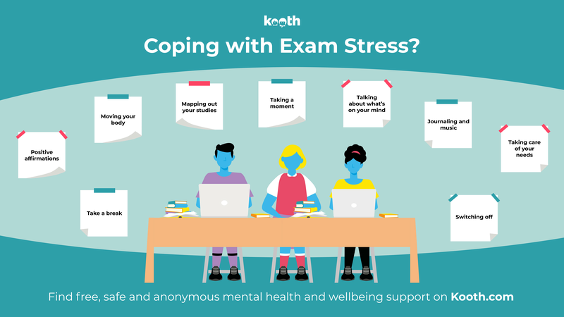
Our Managing Exam Stress workshops were really well attended last month and booked up very quickly. Whilst we know that exams are now well under-way, we wanted to share with you the recorded workshop to share either with those who were not able to join the live sessions or for those who may like to look back on some of the hints and tips.

The Kooth Managing Exam Stress workshop recording can be found HERE.

Support for Schools -
Kooth Young Males Mental Health Workshops

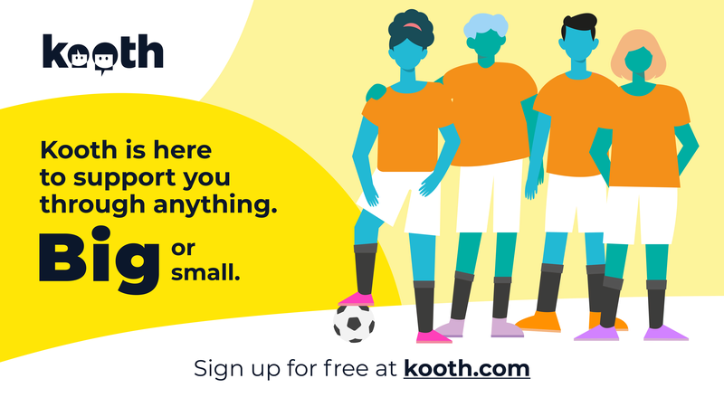

FREE, SAFE & ANONYMOUS SUPPORT FOR YOUNG MALES' MENTAL HEALTH & WELLBEING
at www.Kooth.com - online support for young people

We recognise that often young men have a barrier to receiving support and this can be for a number of reasons, some of which we have identified in our Kooth Pulse report and created a workshop in support. Mental health support for young men is so important.

Kooth has created a male targeted workshops designed to help young men identify, manage and get support for any questions or worries they may have.

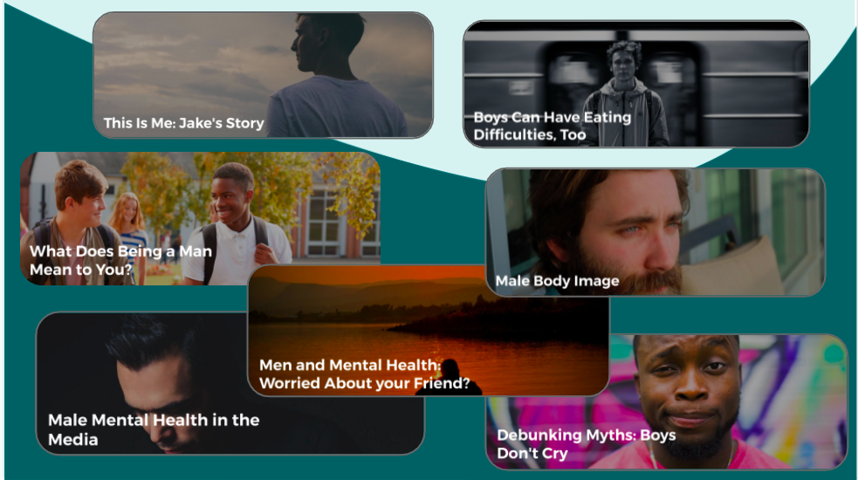

Please contact your local Kooth Engagement Lead to book a workshop or receive a recording for lessons and focus groups.

-What we offer-

-Free counselling from BACP accredited counsellors-
- Digital round the clock availability, enabling the likelihood of engagement-
-Free resources and support for your organisation-
-Free staff training on Kooth services-
-Class and group awareness workshops-
-Self help tools to build resilience and confidence-

We also have male focused posters and cards that we can send in support of your pending workshop or awareness day.
Support for Schools -
Regional Transition Workshops for Y6 Pupils

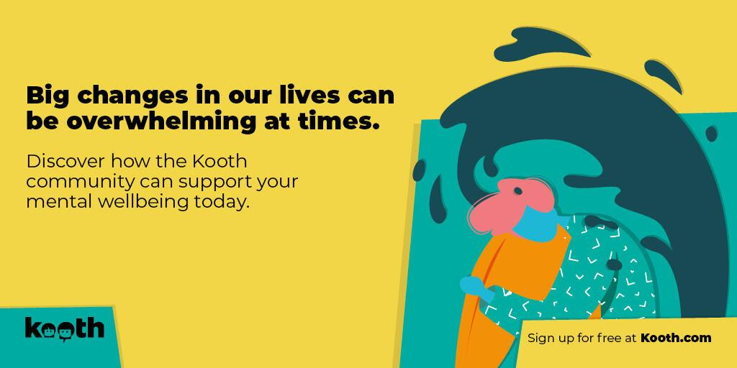

Welcome to Kooth's regional transition workshops for June 2022

The workshops will be delivered by Kooth Engagement Leads and will include:
- Exploring thoughts and feelings year 6 students may have in preparing for secondary school.
- Techniques and coping strategies will be shared to support the stress and anxiety of being in a new educational environment.
- Information and advice on building resilience and understanding their surroundings.
- Self care and positive thinking will be discussed throughout.
- Guided Sign up to Kooth alongside mini activity examples.
- Follow up resources will be shared such as the mini activities booklet, pre-recorded assemblies and links to your local Kooth Engagement Lead

* Safeguarding statement: During each regional session all participants' cameras and mics will be off, each zoom will display as a webinar meaning only the hosts cameras will be visible.

There will be a series of workshops taking place in June
21st/22nd/23rd June and 27th/28th/29th June
All sessions will take place 2pm-3pm on Zoom

To sign up please register through the Google form - 2022 Kooth Transition Workshop

If you have any questions, please do feel free to contact Cheryl Allright at
CAllright@kooth.com

Information for parents / carers

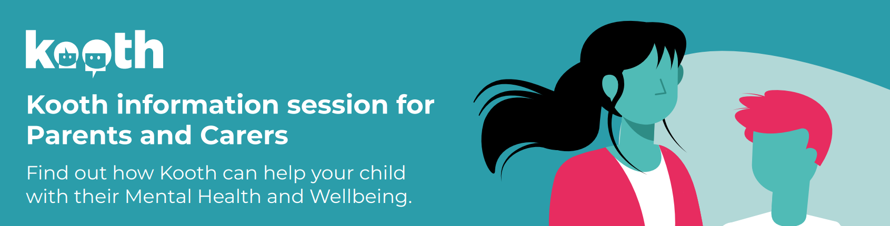

Kooth's London and South East team offer monthly information sessions for parents & carers interested in finding out more about Kooth services. Please provide the link below to parents/carers. Kooth can also provide letters for schools to share with parents / carers explaining what Kooth is and that their child may hear about it through school as a support for them should they need it. Please contact your Kooth Engagement Lead to request these letters and other support resources for parents.

The link for parents/carers to book the free information session can be found here:

Tuesday 7th June 2022, 6pm-7pm
https://www.eventbrite.co.uk/e/introduction-to-kooth-for-parents-and-carers-tickets-277457000357

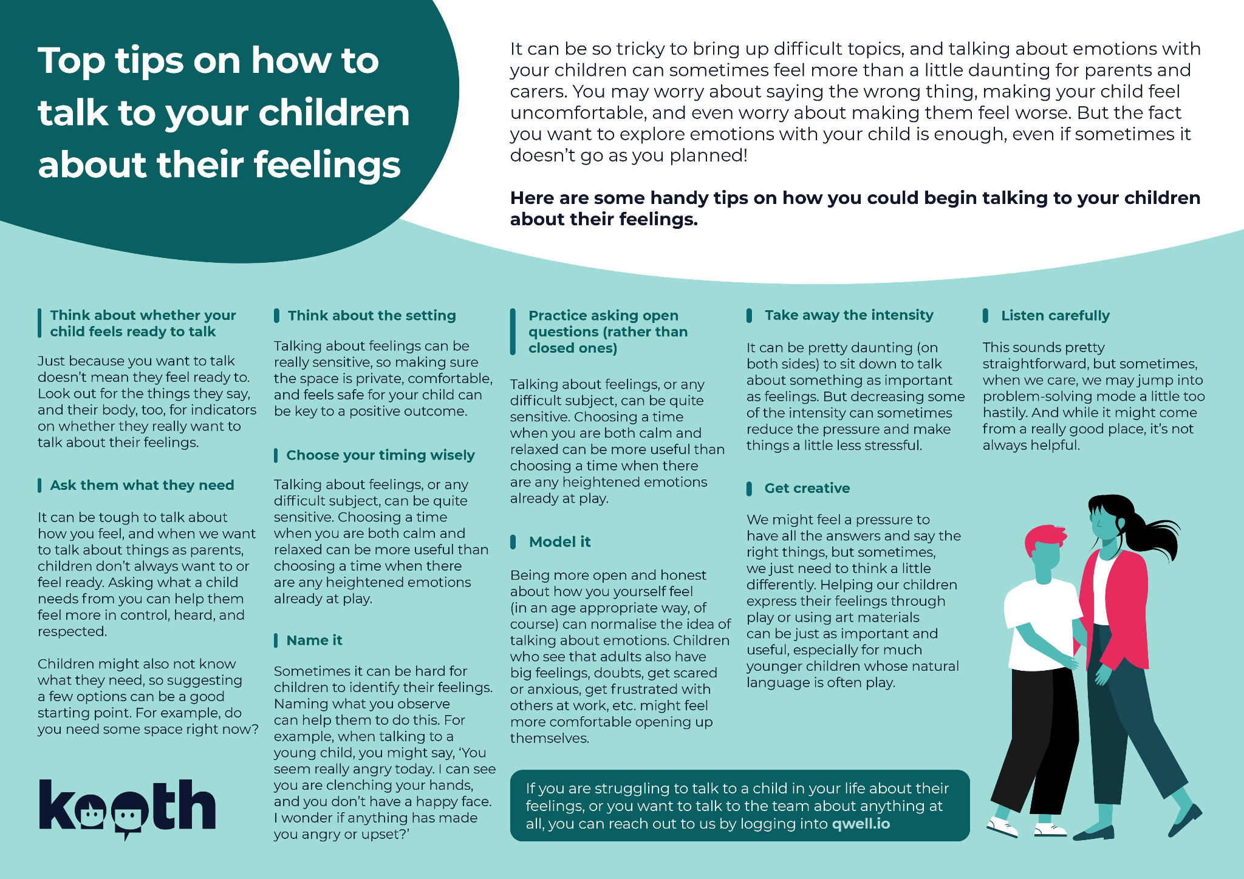

These helpful tips from Kooth's clinical team can help parents and carers start to talk to their young people about their feelings.

It can be so tricky to bring up difficult topics, and talking about emotions with your children can sometimes feel more than a little daunting for parents and carers. You may worry about saying the wrong thing, making your child feel uncomfortable, and even worry about making them feel worse. But the fact you want to explore emotions with your child is enough, even if sometimes it doesn’t go as you planned!
If this feels familiar for you, you are definitely not alone!

If you want to read more about Kooth and the support we offer for your child or young person, you can download our Parent and Carer brochure here.

Support for Adults - Qwell

Our Qwell service for adults continues to grow and we are delighted to share that in the London & South East region everyone in Norfolk & Waveney over the age of 11 years can now access support through either our Kooth or Qwell services.

Our latest adult focused report, Supporting Adults with Stressful Life Events in a Digital Service, can also be found here.

What's On Kooth - June 2022

Kooth will be hosting a series of discussion boards, live forums, podcasts and Magazine content in celebration of Pride Month this June.

Young people can find out more by signing up to Kooth at kooth.com and following the instructions below.

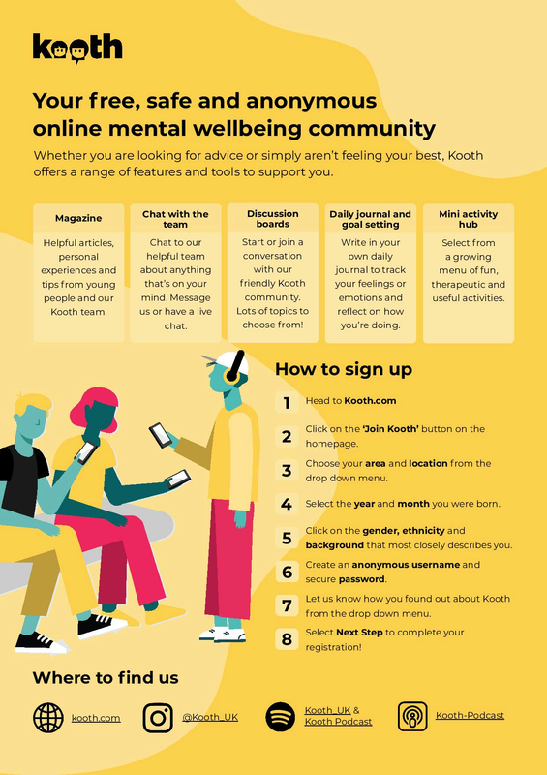

Kooth's Mini-Activity Hub
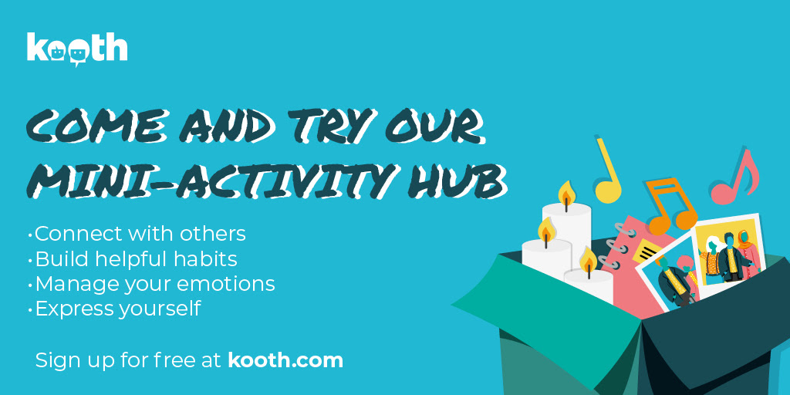

This Pride Month why not unleash your superpowers by doing something creative! Expressing your creativity can be fun and also uplift your mood. You could use this activity as a way to celebrate what makes you unique, focus on and enhance your individual strengths, or imagine yourself without limits.
Why not have some fun and 'Create your own superhero'?

Step 1: Think about what powers you would have if you were a superhero (e.g. invisibility, the ability to fly, turn yourself into something else etc.)

Step 2: Think about what you’d do if you had these powers. Would you do something to help others, help yourself, animals or even the environment?

Step 3: Think about what your outfit would be.

Step 4: Think about your superhero slogan.

Step 5: (Optional). Draw or create your superhero and take a look at your masterpiece!

Some little Kooth extras......

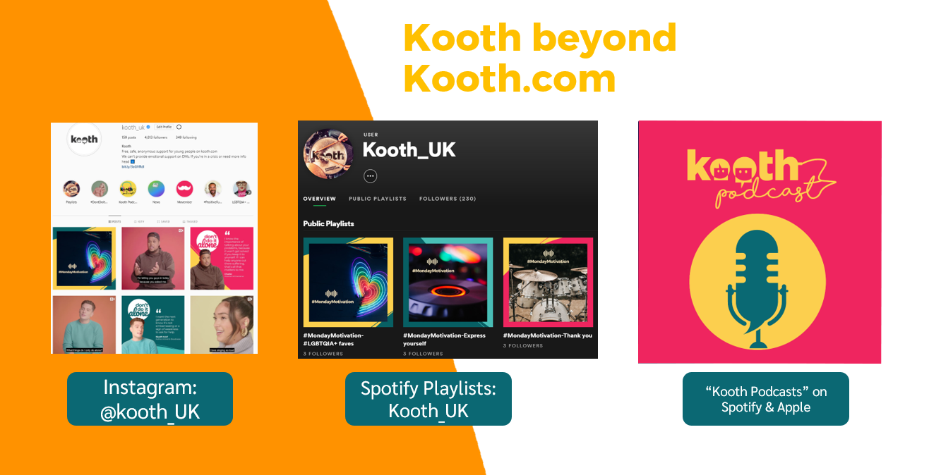

You can find Kooth on Instagram, as well as on Spotify & Apple

Kooth has a range of playlists, from Motivational Mondays to Pride Anthems, which you access on Spotify by searching Kooth_UK

Also, make sure to check out our latest Kooth podcasts.

Click the links to listen on Spotify or Apple Podcasts

