Wider Comms for Enfield Schools

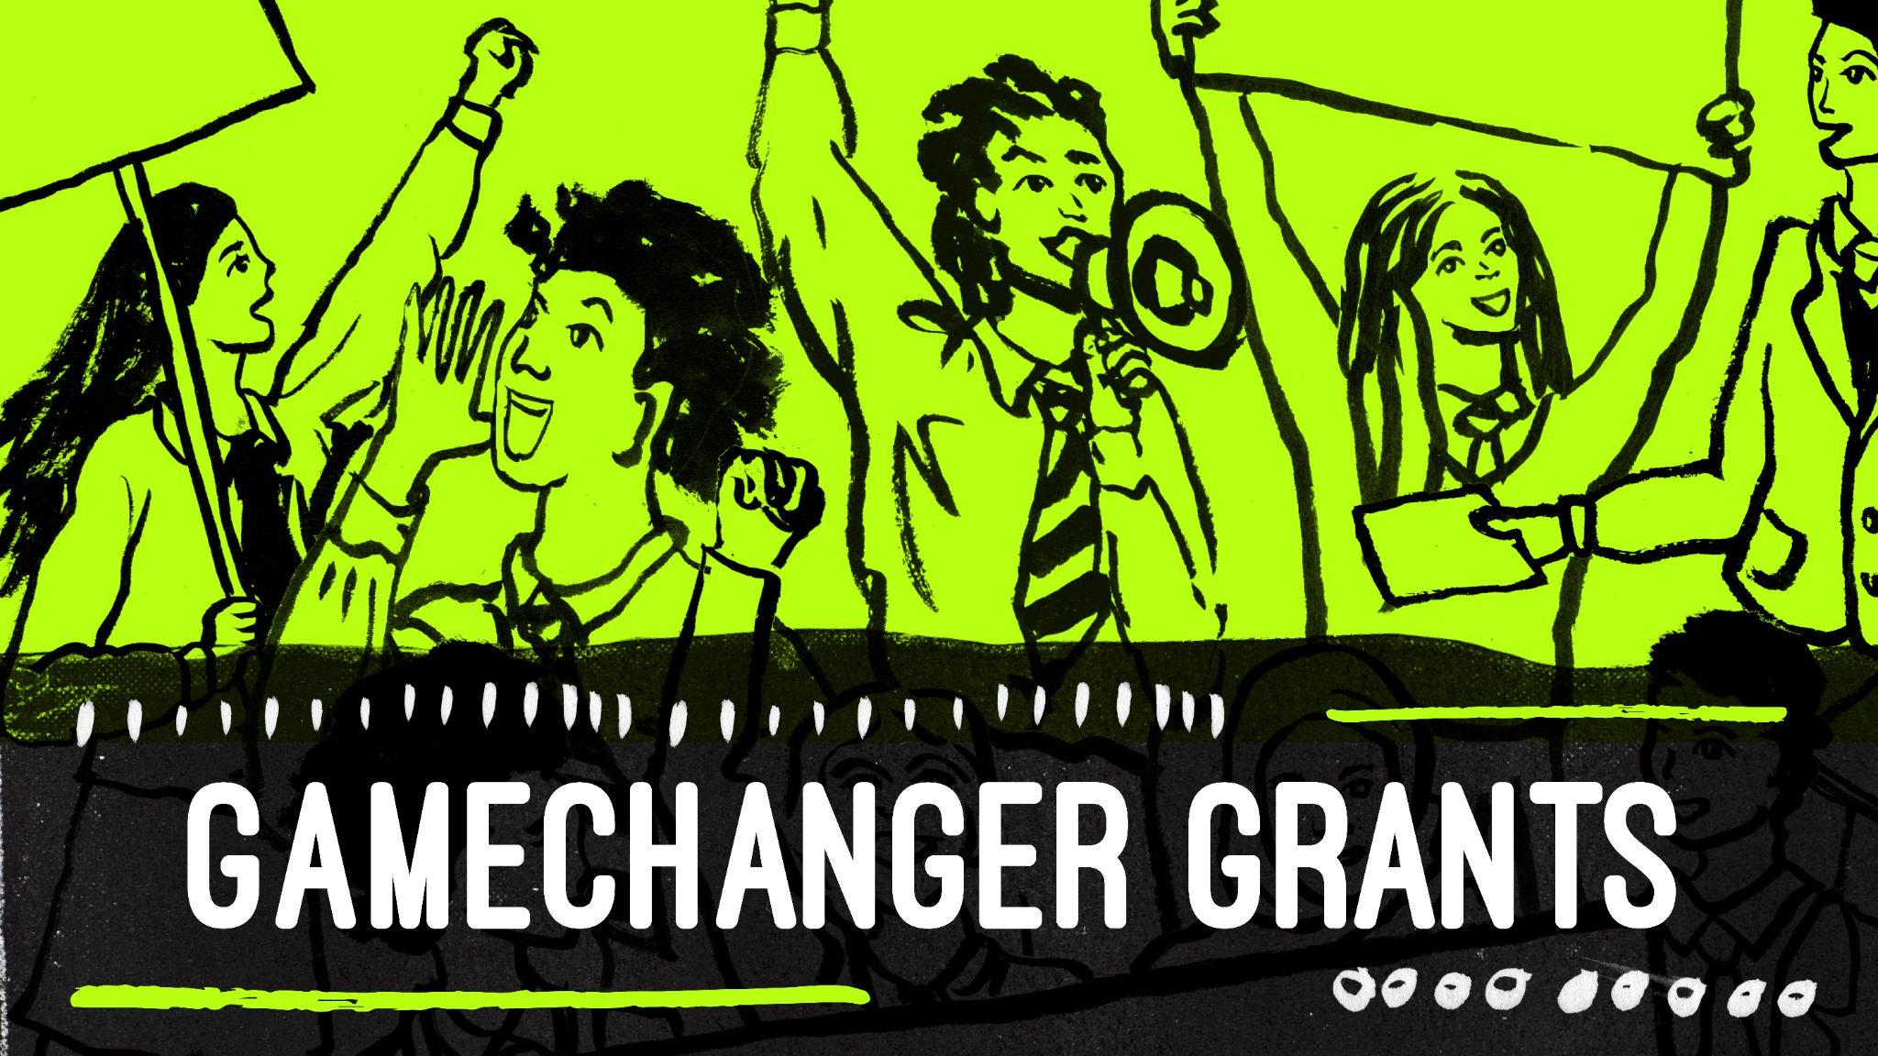

GameChangers is back, supporting more young Londoners to take positive action in their schools and communities. This year we are supercharging community action by awarding small scale grants to students to turn their ideas into reality!

Students will be supported to advocate for issues they care about and pitch for how they would make London a better place in an online letter writing workshop. To register your school and find out how you can get a grant follow the link below. Our next sessions will be taking place on 30 November, 1 December and 2 December.

GameChanger Grants is part of Young Ambassadors, the Mayor of London’s community action programme for schools. Suitable for Key Stage 2 and 3.
Sign up now

