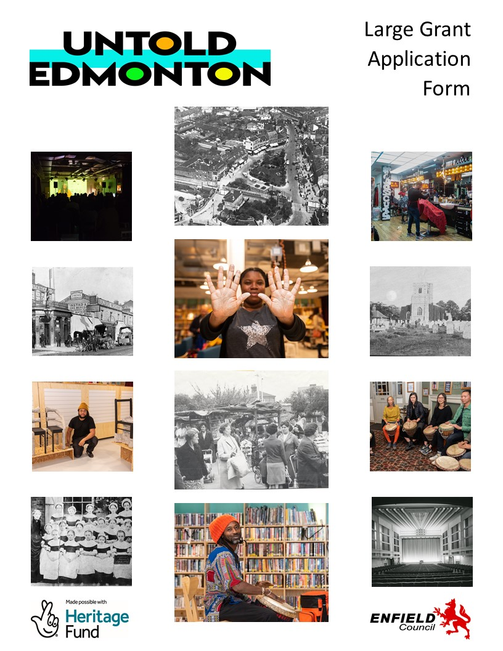

INTRODUCTION

Untold Edmonton is looking for projects that share and celebrate important stories about Edmonton. This community grant application form will help us understand what the story is that you want other people to know about, the type of project you would like to deliver and how we can support you. We can help with applications so please do ask!

- Funding - There are two grant programmes for Untold Edmonton. This form is for the large grants programme. Grants are available in-between £4000 and £9000. You can apply for any amount in-between these two figures.

- Guidance - please refer to our guidance document when filling out this form. All sections of the form must be filled in.

- Support – if you would like advice or support with your application please contact Cultural Heritage Development Officer - Dorian Knight on: dorian.knight@enfield.gov.uk for a 1-1 discussion.

- Deadline – you can apply to meet any of the following deadlines:

- 1st December 2022
- 1st May 2023
- 1st November 2023
- 1st February 2024

You must start your project within 8 weeks of receiving funding.

All projects and activities must have finished by December 2024.

- Submitting Your Application - Please email your completed application forms to Dorian.Knight@enfield.gov.uk. If you would prefer to submit with a paper copy of your application, please contact Dorian Knight on 077866276784 or on the email address listed above.

Section 1: About you

Name of organisation or individual
Contact person’s name
Description of organisation

If you are applying as an individual write ‘individual’
Organisation or individual’s website (if you have one)
Correspondence address (please include the full address and postcode)
Contact email address
Contact phone number

Section 2: About your Edmonton story

A | Please describe the story your project will explore (max 300 words)
B | Why is this an important story for Edmonton? (max 300 words)

Section 3: Tell us your project idea

A | Name of your project (max 25 words)
B | Please describe your project idea (max 300 words)
C | Proposed start date and finish date of project (if known)  Please mention any fixed key dates in your project
D | Where will the project take place (if known)?  Please write the full address of the venue (s) for any planned public activity  (Please note all events must be held in Edmonton)
E | Who are the people involved in creating and delivering your project? (max 300 words)
F | What will be the result of your project? Exhibition, festival, poetry competition, film etc.?
G | How will you let people know about your project? (max 300 words)
H | How will you know your project has been a success? (max 300 words)

Section 4: How much will your project cost ?
A - Please tell us as best you are able how you plan to spend the Community Grant, listing each item below. Please note that you can apply for a grant of in-between £4000 and £9000.

Item | Details | Cost
 | Total | £

B | Are you contributing any financial resources to this project? For example, from any additional funding. | ☐ Yes ☐ No
C | Are you contributing any non-financial resources? For example, space for project activities. | ☐ Yes ☐ No

Section 5: Finishing your project application

I hereby certify that the information contained in this application is correct and in accordance with the best information available to me. I undertake to provide additional information as Enfield Council may require to consider or verify my application. I further confirm that if the application is successful, we will comply fully with the grants programme’s conditions.

Name:
Position:
Signature:
Date:

Data Protection Privacy Notice:
The data controller for this project is London Borough of Enfield (LBE).

London Borough of Enfield gather and process your personal information in accordance with this privacy notice and in compliance with the relevant data protection law. This notice provides you with the necessary information regarding your rights and obligations, and explains how, why and when we collect and process your personal data.

London Borough of Enfield’s registered office is at Civic Centre Silver Street Enfield EN1 3XA

Our designated Data Protection Officer can be contacted by email: enfield.data.protection.officer@enfield.gov.uk

You may read the full contents of the council’s data protection officer here: https://new.enfield.gov.uk/services/your-council/data-protection-policy-your-council.pdf
Conditions of the Community Grant

- The project activities or events must be targeted at Edmonton and bring direct benefit to the borough’s residents. The project must explore and/or celebrate an aspect of Edmonton’s cultural heritage.

- The Community Grant must only be used for the purposes set out in the application form or approval correspondence, unless changes are agreed by the Council in writing.
- The project or event organisers shall not use any part of the Community Grant to support any political party or to engage in publicity, which could reasonably be regarded as designed to affect support for a political party.
- The Community Grant may not be used for the purchase of alcohol.
- The Community Grant may not be used to subsidise fundraising activities.
- The Community Grant must be spent and accounted for, within eight weeks of completion of the project activity, and submitted with other required project monitoring information.
- The Community Grant cannot be used for expenditure made before the date of your grant offer notification.
- Proper financial and accounting records must be maintained.
- All project literature should include the Untold Edmonton brand, as well as any partner brands, as appropriate.
- Enfield Council’s Cultural Heritage Development Officer will be assigned to the funded project to provide liaison as necessary. This representative must be kept informed of the progress of the project.
- Monitoring information must be provided as specified in the Community Grant offer notification and access given to the project at all reasonable times in order that Enfield Council’s Cultural Heritage Development Officer may provide development support and carry out monitoring and evaluation duties as appropriate.
- The project must be inclusive of all sections of Edmonton’s community and operate good practice in equal opportunities.
- The project organisers must comply with all legal requirements in relation to employment, insurance, health and safety, child and vulnerable adult protection, service delivery, premises and other relevant matters.
- Funded projects will be expected to share information on their activities, outcomes and achievements, as and when required by the Council.

