Enfield Risk Assessment Plan (RAP)
for Children/Young People who display
Sexually Harmful Behaviour
in an Education Setting

Introduction and guidance
This guidance has been produced to provide educational establishments (including
Maintained Schools and Nursery Schools,Academies, Free Schools and Independent Schools,
Sixth Form Colleges and Colleges of Further Education) with:

- an awareness of age-appropriate sexual behaviour
- guidance for evaluating inappropriate sexualised behaviour
- a framework for educational establishments to manage and review this behaviour

The Education Act 2002 outlines that Local Authorities and School Governing Bodies have a responsibility to “ensure that their functions relating to the conduct of school are exercised with a view to safeguarding and promoting the welfare of children who are its pupils”.

Education settings are an important part of the inter-agency framework not only in terms of evaluating and referring concerns to Children’s Services and the Police, but also in the assessment of risk that the child or young person may pose to themselves and others in the education setting. As part of the overall management of risk, schools must ensure that all the children and young people in their care are kept safe from harm (Keeping Children Safe in Education 2022.) Education staff have valuable information and skills which are useful to support the specific work that may be undertaken by other agencies and collaboratively providing a consistent approach to the management of the child/young person’s inappropriate sexualised behaviour.

This guidance aims to ensure that education staff have a common understanding of the issues and a consistent and common framework for assessing, reporting, and managing the risks that these children/young people may pose to themselves, peers and their communities.

When sexualised behaviour has been observed or, a child or parent has informed staff that such behaviour has taken place, then staff should inform the Designated Safeguarding Lead for who will clarify the exact behaviour which has taken place and make a considered assessment of its nature and decide appropriate next steps.

Your consideration should determine whether the incident/behaviour is:

- age-appropriate sexual exploration
- inappropriate sexual behaviour which is not considered to be problematic or harmful
- Problematic and or harmful sexual behaviour
- Serious Sexual Violence and Sexual Harassment (SVSH) and that may constitute a criminal offence.

Please refer to the DfE guidance; https://www.gov.uk/government/publications/sexual-violence-and-sexual-harassment-between-children-in-schools-and-colleges

Harmful sexual behaviour framework NSPCC and Professor Simon Hackett framework
https://learning.nspcc.org.uk/research-resources/2019/harmful-sexual-behaviour-framework

If you have concerns that a child is at immediate risk of harm you should call 999.

If you consider a child young person may be suffering, or is at risk of suffering, significant harm and is in need of protection and care because of neglect, sexual, physical or emotional abuse please make a referral to MASH via our children’s portal Child Protection Referral (enfield.gov.uk)

If you have a safeguarding concern that cannot wait for completion of a referral form you should call the MASH on 0208 379 5555.

If a young person has caused serious sexual harm to a peer inform the police on 101

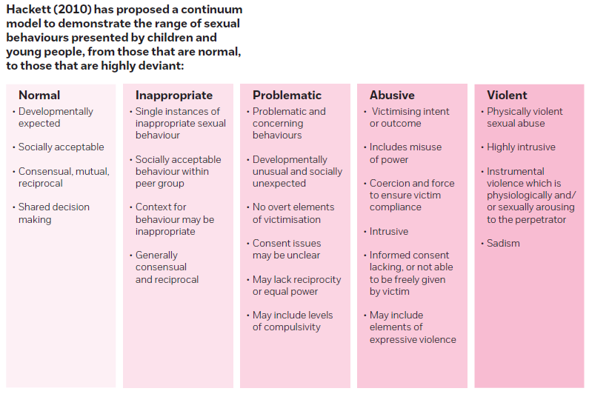
Initial consideration of the concerning behaviour

https://learning.nspcc.org.uk/media/1657/harmful-sexual-behaviour-framework.pdf

The Risk Assessment Plan (RAM) is the school/college's process for identifying and managing risk arising ONLY from a child’s or young person’s problematic sexualised behaviour.

Once the need for a RAP has been identified, the process should run as follows:
- Speak to parents
- Speak to child/young person/s (CYP)
- Seek advice if necessary, from Children’s Services or a CYP social worker, key worker or relevant other professional
- If police are involved seek guidance regarding their view of level of risk
- Consider who needs to know, while ensuring confidentiality
- Record keeping, this document should be kept in a secure place.
- If you require support with your planning, contact your Designated Child Protection School Liaison Officer
- Complete the plan set out on page 5, engage the CYP and parent and carers (if applicable)
- Please only use the Brooks Traffic Light tool if you have received the training. Please use the tool to assess the sexualised behaviour and include the assessment within the risk assessment below.

PARENTAL CONSENT
Whilst it is not necessary in certain circumstances (age of child or they may be out at further risk) to have parental permission to implement a RAM it is preferable that you do. Parents and carers should be involved early on in the process to support their CYP.

Risk Assessment Plan (RAP)
for Children/Young People who display
Sexually Harmful Behaviour
in an Education Setting
Name of child/young person
Date of birth
School/College

Class/Form

Date of RAP

RAP agreed by:
Name | Role | Section of RAP to be shared
N.B. Parents and the child/young person concerned should be part of the plan, along with key agencies/professionals

Information sharing:
In order to safeguard children, the contents of this RAP may need to be shared with other professionals on a need to know basis. The parents/carers and child (if appropriate) will be informed of who the RAP is being shared with and why.

N.B.The RAP (Day to day management plan) should be shared with any key staff members involved with the child, e.g. class teacher.

Context of RAP/overview of the concerns:
Give an overview of the incident/reason you are undertaking this RAP
Please refer to any existing safeguarding documentation which you may have on file

Factors causing concern and evidence
Please elaborate nature of harm in behaviour box as necessary, e.g. risk of reprisals

Behaviour | Nature of harm?  (physical, sexual, emotional)  P/S/E | Fact or potential risk?  F/PR | Deliberate/ Accidental/  Involuntary (if known)  D/A/I
Harm to self
Harm to peers
Harm to staff
Other Harm (please specify)

Other Harm (please specify)

Other agencies views of concern/s:
Children and young people’s needs are often complex and require a joined up response by a range of agencies. This document should reflect the views of other agencies about the level and nature of risk.

 | Factors that heighten risk | Factors that lower risk
School

Health

Police

Children’s Services
Please identify which service/s
specifically, are working/have worked with the child below

Other

Checklist of things to consider

This list is for use when completing the day-to-day management plan’ (page 5). The headings correlate to the trigger titles in the table on page 5 and should help you to complete the ‘strategies to support’ section. Please bear in mind that the questions here are just pointers – you are not required to answer every question and the list is not exhaustive. There are blank sections in the table on page 5 should you have additional triggers you wish to highlight
Teaching and learning
- What is the current level of supervision and is this appropriate?
- Are all staff aware of the level of supervision required?
- Who is responsible for discussing the child/young person’s risk and needs with other staff?
- Has the child/young person engaged in any worrying sexual behaviours within the classroom setting now or previously?
- Are there particular times when the child/young person seems more relaxed and content?
- Are there particular times or circumstances where the child/young person seems more unhappy/upset/distracted/irritable/distressed?
- Can extra support/supervision be put in place during difficult times?
- Are the seating arrangements satisfactory?
- Are there times when the child/young person is allowed to leave the class during class times?
- How is sex and relationships education managed and does the child/young person need further information?
- Are there particular areas of risk in the class e.g. when the teacher is occupied with other pupils, and how can this be managed?
- How will risk be managed during off site activities – school trips, work experience etc?
Unstructured times
- Have there been concerns about the child/young person’s sexual behaviours in school when out of the classroom? If so, who were the behaviours directed to and in what circumstances? What children may be particularly vulnerable and how can this be managed?
- Does the location of the toilets cause a problem? Does more than one class share them? Are particular rules required for going to the toilet?
- Are there rules about showering, dressing and undressing for PE that need to be considered? Are staff able to supervise changing appropriately and according to the needs and age of the children concerned?
- Are there rules about physical contact during play that needs to be considered?
- Has the child/young person a history of absconding?
- Does consideration need to be given to use of school technology? Is school technology (computers, laptops, tablets, iPads etc) monitored to ensure that children and staff are following the School’s Acceptable Use Policy?
- What are the arrangements for the child/young person to get safely to and from school/college?

Outside area
- Are there areas within the school and grounds that are unsupervised?
- Are there any other building issues that may increase risk? e.g. building works, co-located school, communal playground?
- Is there a need to make certain areas ‘out of bounds’ either for the time being or permanently?
- Can you involve more staff to engage children in constructive play/conversation to encourage them to be more interactive and, therefore, less open to inappropriate play/activity?

Children/Young People
- Have all children been taught about keeping safe? Is any additional input needed due to the current concerns (either individual/group work or as a whole class) Who will take responsibility for coordinating?
- Are all children aware of who they can go to if they have a worry?
- Do all children feel that they are listened to and are confident that appropriate action will be taken?
- If primary, have all children completed a Safety Circle (Foundation/KS1) or a Network of Support (KS2)?
- If secondary, are young people aware of who they can speak to/who their support networks are in school (including school nurse, DSL’s etc)?
- Are children’s parents/carers informed of personal safety curriculum Units of Work covered, including E-safety?
Individual work
- Who will talk to the child/young person about their sexual behaviours if the need arises? Will this staff member require any support?
- What are the arrangements for reporting, recording and monitoring the child’s behaviour? Who will be responsible for monitoring and updating the chronology?
- Are there clear boundaries and expectations of acceptable behaviours?
- What work is being undertaken to address the child’s unmet needs in relation to sexual behaviour?
- What support has the child/young person been offered to be safe in school?
- What support is in place to reduce the risk of isolation and to encourage the child to enjoy and achieve?
- Are there any additional factors to consider in relation to the child’s age, sex, race, religion, disability, mental/physical health or other?
- Who will communicate with parents/carers? What support needs do the parent/carers have? What do parents/carers need to do to support their child?

Day-to-day Management Plan

Please complete the relevant section/s using the ‘Checklist of things to consider’ on page 8:
- Teaching and learning | - Unstructured times
Potential triggers: Strategies to support: | Potential triggers: Strategies to support:
- Outside Area | - Children/Young People
Potential triggers: Strategies to support: | Potential triggers: Strategies to support:
- Individual Work | - Other Trigger (please specify)
Potential triggers: Strategies to support: | Potential triggers: Strategies to support:

Please ensure that all staff who are involved in the implementation and monitoring of this day to day management plan can answer the following questions:
- Are you aware who the Designated Safeguarding Lead (DSL) is/are?
- Are you aware of who to go to if the DSL is not available?
- Are you aware of the need to record concerns and pass them on to the DSL?
- Are you familiar with the contents of child protection and/or safeguarding policy?
- Have you received Safeguarding Children Training within the last 3 years?
- Have you received information about safer working practice and a protective ethos in school?
Review of RAP

Evaluate whether any changes need to be made to the RAP. A Review will consider any new information, change in circumstances, and any work carried out with child and family

Agreed actions/amendments for this review:
Summary of progress made | Actions/amendments | Why? | Who and when?
School/College setting:
e.g. have there been any further incidents? If so, what actions were taken and what was the outcome?

Child/young person:
e.g. has the child used the support available in school and from other agencies as part of this plan?

Response to increased concerns (if there are concerns that the Day-today Management Plan on page 5 is ineffective)
e.g. can the child remain in school given the current concerns? What additional support can be given?

Review actions and amendments agreed by:
Name | Role | Signature
4.4 Date RAP reviewed 4.5 Date of next RAP review
………………………………………. ……………………………………….
The timescale of the review needs to be in proportion to the level of concerns/risk and the degree of support and intervention

