Schools Health and Safety Newsletter

Autumn 2025

Welcome back!

We hope you have all had a restful break as we start the Autumn term.

Prosecutions

Site supervisor fined after exposing school pupils to asbestos

A construction site supervisor has been fined after he exposed primary school pupils and staff to asbestos during renovation work.

The supervisor was working as a site supervisor during the refurbishment of kitchen facilities at Holy Family Catholic Primary School in Bristol.

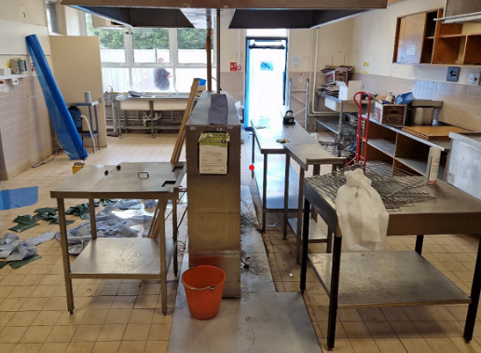
The supervisor cut through asbestos insulating board using a circular saw. His actions resulted in asbestos fibres spreading throughout the school hall, which was subsequently used for two days by pupils and staff.

Close up of the asbestos containing material

An investigation by the Health and Safety Executive (HSE) found that the site supervisor had failed to follow his asbestos awareness training, including clear instructions not to disturb the wall.

Following an asbestos survey, the wall was due to be checked by a licensed asbestos contractor prior to removal to clarify if asbestos was present.

We would advise that all schools arrange for their appointed person and deputy to attend training or refresher training for asbestos, if this has not already been done.

Please email shst@enfield.gov.uk to arrange.

Appointed Person and deputy responsible for Asbestos and Legionella
Emma will shortly be sending out a form for schools to complete. This is to update our central list for the Appointed Person and Deputy Person responsible for asbestos and legionella. We would appreciate it if schools complete this and return to SHST@enfield.gov.uk. Thank you.

Providing/Lending equipment to contractors
We would like to remind schools that contractors should have their own equipment when working at your site.
It is the schools’ responsibility to ensure contractors work safely on your site, but the contractor’s responsibility to provide their staff with the correct equipment. The contractor would also ensure that the equipment is suitable for the job, in a safe condition and that the workers are trained to use the equipment, along with providing schools with risk assessments and methods statements (RAMS) of the work to be carried out.
An example of the risks by lending equipment, both to contractors and more generally, is the 2010 case of a contractor who fractured his skull and sustained nerve damage after falling from a ladder and between the decks of a client’s boat. The owner of the boat, having provided the unsuitable and unsafe ladder from which the contractor fell, was prosecuted for the injury.

Accident/Incident/

Fire and Violence & Abuse Reporting

We would like to take this opportunity to remind schools of the SMARTAA system (the accident, incident, fire and violence & abuse reporting system). Please see below examples of reporting.
Accident – an unplanned event that results in injury or ill health to staff and members of the public. (For the purposes of reporting a member of public includes pupils).
Incident – an incident where someone has been taken ill but no accident occurred or a serious incident such as a collapse of a wall.
Violence & Abuse – all incidents of violence and abuse against staff should be reported.
Fire – all fires that occur on school property
Reporting to the HSE for anything that meets the requirements of The Reporting of Injuries, Diseases and Dangerous Occurrences Regulations 2013 RIDDOR will be completed by our team.
If you have any queries, please get in touch.

School Health & Safety Audits and Fire Safety Audits

We would like to remind schools that health and safety, and fire safety audits are to be carried out by the Schools Health & Safety Advisor and Fire Safety Advisor every two years.

The health and safety audit and fire safety audit are an assessment of a school’s health and safety policies, systems, and procedures. The audit aims to identify areas for improvement, ensure compliance with regulations, and enhance overall safety performance. Both Julia and Rupert can fully support schools where needed.

If you are a community school, you will be contacted by either Julia Moulton or Rupert Funk to arrange this.

If you are a non-community school (i.e., voluntary aided, academy, foundation or independent school), please remember that as part of your Service Level Agreement, Julia and Rupert will be able to provide this for you.

Please feel free to get in touch with either Julia or Rupert to arrange and they will be able to support your school.

Their emails are:
Julia.moulton@enfield.gov.uk
Rupert.Funk@enfield.gov.uk

School Policy Updates

Accident Reporting Instructions (SMARTAA)

Please be advised that there is an updated version of this document available on The Hub. This was also recently sent out to schools.

Radioactivity Policy and Guidance
If you are a secondary school and hold radioactive sources, please be advised that there is now an updated Radioactivity Policy and Guidance document. This is now available on The Hub. Please can you ensure that the Head of Science has seen the policy. Thank you.
Julia will be arranging to visit all the schools who hold these sources to carry out an audit over the
DSE Self- Assessment Form
The DSE Self-Assessment form has also been updated. This was sent to all our schools and is available on The Hub.

Training

An email went out recently to all community schools and those that have a Service Level Agreement with us regarding the training rooms at the Civic Centre rooms.

Please be advised due to circumstances out of our control some of the venues for the health and safety have changed or have become virtual.

We would advise our schools to check that you have the most up to date information.
Please email SHST@enfield.gov.uk if you need further information.
Paediatric First Aid training
We have been asked to remind you by the Early Years Team based here at the Council that training is available with them. Please email for further information EYtraining@enfield.gov.uk

As always, please feel free to get in touch if you need any assistance or would like to book training.

shst@enfield.gov.ukor telephone the team telephone number
020 8379 3223

Many thanks.
Julia Moulton
Emma Young
Stephanie Partou
Schools Health & Safety Team

