Scope | These terms of reference for the Children/Young Peoples Autism Partnership Group sets out how partners will work towards the priorities set within the All-Age Strategy.
Document Author | Suzy Francis (Principal Educational Psychologist/Strategic Lead for Emotional Wellbeing and Mental Health & Autism)
Governance Board | SEND Partnership Board / Youth Justice Strategic Management Group
Version | Draft v.1 ~ July 2025

Children/Young Peoples Autism Partnership Group
Terms of Reference
- Vision
It is important we listen to and learn from autistic people with lived experiences and make sure we identify and remove any barriers preventing access to education, employment, health and social services and making contributions to our society. We will work as a partnership to help make this become a reality and improve the lives of autistic people and their families and carers in Enfield.

- Purpose
To establish a multi-agency working group that reports to the SEND Partnership Board / Youth Justice Strategic Management Group with oversight of the following principles and priorities agreed under the strategy;
Principles:

- Ensure children, young people, adults, and families are valued and respected and are involved in decision making about themselves, their future and their borough
- Empower and enable all children, young people, adults, and families to be as independent as they can be.
- Deliver accessible joined up services and share good practice to increase the quality of provision.
- Make sure that Enfield is a positive place for autistic people to learn and thrive through making reasonable adjustments to the environment across our settings, services and programmes.
- Identify needs early and provide the right support, in the right place, at the right time to avoid future crises.

Priorities:
Priority 1; Celebrate autistic people
Priority 2; Provide needs-based support
Priority 3; Enable fair access to education
Priority 4; Support more autistic people into employment
Priority 5; Recognise and combat isolation and loneliness
Priority 6; Provide inclusive mental health and wellbeing support
Priority 7; Improve support within the criminal and youth justice systems

A planning group representing Education, Health and Social Care will meet to set out the forward plan and ensure the following priorities are brought to group for discussion and links to other action plans across partners.
Children and Young People Priorities | Refs to Autism Strategy | Refs to SEND Action Plan | Refs to Health Action Plan | Refs to… | Refs to…
Celebrate autistic people

Provide needs-based support

Enable fair access to education
Support more autistic people into employment

Recognise and combat isolation and loneliness

Provide inclusive mental health and wellbeing support
Improve support within the criminal and youth justice systems

- Frequency of meetings
Meetings to be termly as a Children and Young Peoples Autism Partnership Group with one annual meeting to be joint with Adults Autism Partnership Group. Subgroups will be formed to undertake focused pieces of work as necessary.
(Note: the Adults Autism Partnership meets quarterly)

- Chair / Minute Taker
The chair(s) are Claire Collins (Senior Lead Educational Psychologist) and Rachel Walker (Head of EASA). The minute taker will be a member of Strategy and Resources. The attendees will comprise Enfield Council, North London Foundation Trust, North Middlesex Hospital, Integrated Care Board representatives, representatives from Our Voice Parent Carer Forum and supported by members of the local autistic community.
- Reporting Arrangements
The group will report to the SEND Partnership Board the Youth Justice Strategic Management Group and governance arrangements are set out below;
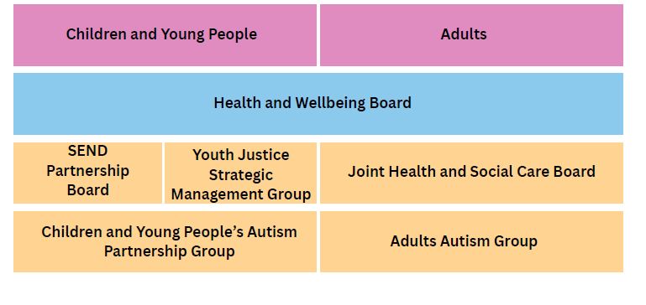

- Statutory Guidance and Key References

- The Autism Act (2009)
- National Autism Strategy (2021 to 2026)
- The Children and Families Act 2014 (Part 3) and Code of Practice for Children and Young People with Special Educational Needs/Disability
- The Care Act (2014)
- NICE Guidelines (2017)
- Fit for the Future: 10 year health plan for England (2025)
- These are our children (2017) – A review by Dame Christine Lenehan

- Core Membership

Organisation/ Service | Representative | Email
Commissioning (Enfield Council)  Children in Care/Care Leavers representing Children’s Services  Designated Clinical Officer  Designated Social Care Officer  Director of Education  Educational Psychology Service  Enfield Advisory Service for Autism (EASA)  Enfield National Autistic Society  Further Education / College rep  Integrated Service for Learning Difficulties  Joint Service for Disabled Children  Learning Disabilities - Autsim  Mainstream School rep  (primary and secondary)  NCL Integrated Commissioning Board (Enfield)  Neurodevelopment Pathway (North London Foundation Trust)  Neurodevelopmental Pathway (North Middlesex Hospital)  Our Voice Parent/Carer Forum  Public Health – Strategy & Policy  Representation from Autistic community  Schools and Early Years Improvement Services (Progression Pathways Lead)  SENDIASS  SEN Service  Special School reps (Russet House & Durants & West Lea) | Caroline Fanning  Karen Alderton  Sally Mordi  Ciara McDonagh  Peter Nathan  Claire Collins  Suzy Francis  Rachel Walker  Natasha Rajamahendra/  Sandeep Chal  TBC  Charlene Thomas  Mirjan Dhamo  Christopher Reddin  Margaret Payne – OLOL  TBC  Suzi Griffiths  Stella Mo  Helen Cooke  TBC  Mathew Cagnetta  TBC  Samantha Hill  Andy Johnson  TBC  Barbara Thurogood  Sarah Kennedy  Rebecca Freedman  Rachel Carli  Cath Goodwin | Caroline.fanning@enfield.gov.uk  Karen.aldertaon@enfield.gov.uk  sally.mordi@nhs.net  ciara.McDonagh@enfield.gov.uk  peter.nathan@enfield.gov.uk  claire.collins@enfield.gov.uk  suzy.francis@enfield.gov.uk  rwalker@enfieldasa.org.uk  branchofficer@enfieldnas.org.uk  Charlene.Thomas@enfield.gov.uk  Mirjan.Dhamo@enfield.gov.uk  Christopher.reddin@enfield.gov.uk  MPayne@ololschool.enfield.sch.uk  TBC  suzanne.griffiths3@nhs.net  s.mo@nhs.net  helencooke2@nhs.net  info@ourvoiceenfield.org.uk  Matthew.Cagnetta@enfield.gov.uk  TBC  Samantha.Hill@enfield.gov.uk  Andy.Johnson@enfield.gov.uk  TBC  Barbara.thurogood@enfield.gov.uk  Sarah.kennedy@enfield.gov.uk  headteacher@russethouse.enfield.sch.uk  headteacher@durants.enfield.sch.uk  cgoodwin@westleaschool.co.uk

- Date of TOR: July 2025

- Review date: July 2028

