Delivering Better Value Steering Group
Terms of Reference

DBV Programme aim: The Delivering Better Value in SEND programme aims to support the London Borough of Enfield and local area partners, to improve the delivery of SEND services for children and young people, whilst working towards financial sustainability.

1 Purpose of steering group
  - Ensure the DBV programme follows the strategic aim, through monitoring and ensuring accountability.

  - Maintain alignment between the DBV programme and DSG management plan.

  - Ensure the DVB programme aligns with the strategic objectives of the Local Area SEND Partnership.

  - Provide influence and endorsement to the Local Area SEND Partnership on the DBV programme.

  - Provide advice, challenge and recommendations to the DBV programme and workstreams.

2 Roles and responsibilities
2.1 Work with the SEND partnership to provide support, direction and challenge to the project outcomes, in the Delivering Better Value programme.

2.2 Monitor the monthly progress of delivery to the agreed outcomes and where required, ensure mitigations are in place.

2.3 Ensure the Delivering Better Value programme, aligns to national legislation and local area plans.

2.4 Monitor grant spending for the Delivering Better Value programme.

3 Accountability

3.1 DBV workstream leads to report to SEN Programme manager.

SEN Programme manager to provide monthly update to DBV steering group. Key decisions to be agreed by Director of Education.

Quarterly reporting to DfE.

4 Governance structure

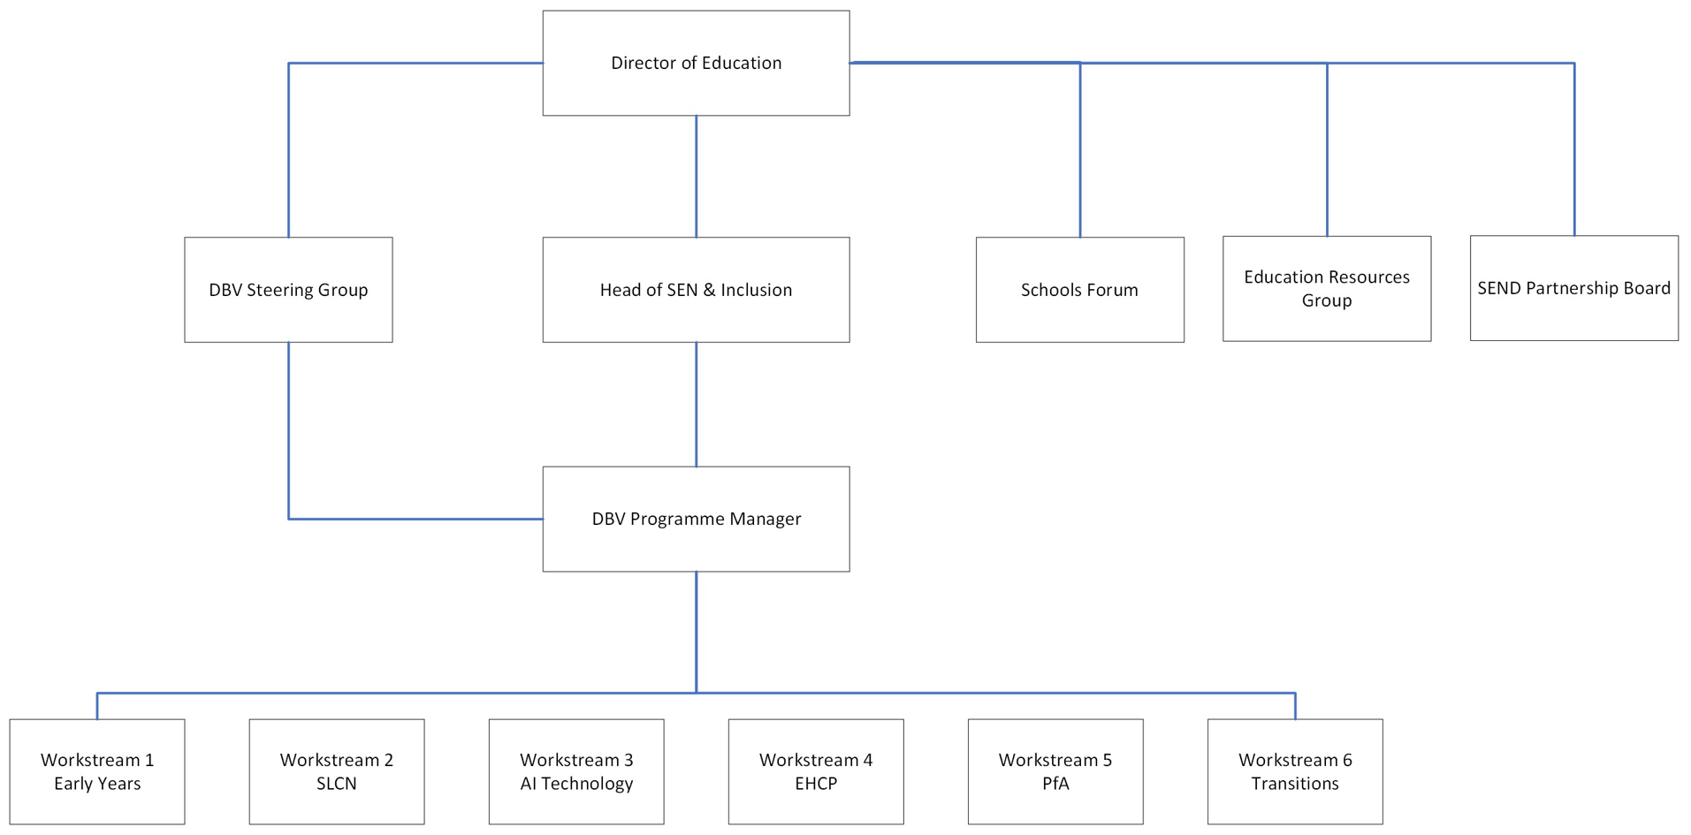

5 Membership

Name | Title | Email
Chair – Sally Mordi | Designated Clinical Officer | sally.mordi@nhs.net
Vice Chair – Barbara Thurogood | Head of SEN & Inclusion | barbara.thurogood@enfield.gov.uk
Peter Nathan | Director of Education | peter.nathan@enfield.gov.uk
Seema Islam | Chair of Our Voice | seemaourvoice@outlook.com
Mirjan Dhamo | Head of Service for Disabled Children | mirjan.dhamo@enfield.gov.uk
Lucy Nutt | Head of School & Early Years Improvement Service | lucy.nutt@enfield.gov.uk
Suzy Francis | Principle Educational Psychologist | suzy.francis@enfield.gov.uk
Andy Johnson | Head of Post 16 Provision | andy.johnson@enfield.gov.uk
Melissa Williamson | Strategic Finance Manager | melissa.williamson@enfield.gov.uk
Andrew Lawrence | Head of Commissioning – CYP & Public Health | andrew.lawrence@enfield.gov.uk
Olivia Bray | SEN Programme Manager, DBV | olivia.bray@enfield.gov.uk
Catherine Lane | Attigo Academy Trust, CEO | ceo@attigoacademytrust.co.uk
Rob Jenkin | Houndsfield Primary, Head Teacher | rjenkin@houndsfield.enfield.sch.uk
Zoe Thompson | Oasis Hadley, Head Teacher | zoe.thompson@oasishadley.org
Tina | Hadley Wood Primary, SENCO | senco@hadleywood.enfield.sch.uk
Kirstie Das | Edact Trust SEND Lead | kdas@edact.org.uk
Nursel Arslan | Dreams Nursery, Manager | narslan@dreamsdevelopment.co.uk
Hushna Utim | Inclusion Lead, Barnet & South Gate College | hushna.utim@barnetsouthgate.ac.uk
Charleen Thomas | Adult Social Care | charlene.thomas@enfield.gov.uk
Donna Wiggins | SENDIASS | donnaw@centre404.org.uk

6 Responsibilities of Board members
6.1 Attend all scheduled steering group meetings or delegate attendance to an appropriate member of staff who has delegated authority.

6.2 Share relevant communications and information across the steering group and where appropriate within own organisations and/or departments, being mindful of information governance and data sharing requirements and legislation.

6.3 Chair will be responsible for clarifying at the end of meeting any areas of discussion that cannot be shared outside of the meeting.

6.4 Make timely decisions and be accountable for any agreed actions required.

6.5 Notify members of any matters which may impact on the effectiveness of the steering group.

7 Frequency
7.1 The DBV steering group meeting will be held bimonthly. This will be reviewed 7.10.25

8 Administration
8.1 Agenda and action log will be distributed at least 5 working days before the meeting and the next meeting date will be made available to members at least 4 weeks in advance.

8.2 The meeting will be Chaired by the Sally Mordi and Barbara Thurogood will act as vice Chair.

9 Conduct of committee
9.1 The steering group will conduct its business in accordance with relevant national guidance and relevant codes of practice.

9.2 If any member has an interest, pecuniary or otherwise, in any matter and is present at the meeting at which the matter is under discussion, he/she will declare that interest as early as possible and shall not participate in the discussions.

9.3 The Chair will have the power to request that member to withdraw until consideration has been completed.

9.4 If the Chair has a conflict, then an alternative Chair will be nominated from the membership of the committee.

Document control
Document history:

Version | Issue Date | Changes
Draft 1 | 25/6/24 | First draft TOR
Draft 2 | 28/6/24 | Second draft TOR
Draft 3 | 5/7/24 | Third draft TOR
Version 4 | 16/7/25 | Updated representatives list

