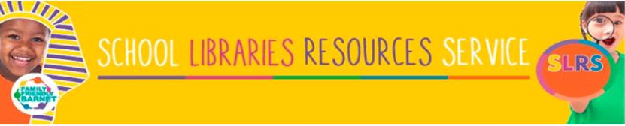

Schools Libraries Resources Service

For Information

The Schools Libraries Resources Service (SLRS) is a subscription service that provides a high quality loan service of books, artefacts and story sacks to primary schools in Barnet, Brent, Haringey and Enfield. Our book loan boxes support curriculum topics and encourage reading for pleasure. We are passionate about the book stock we select; we want children to be excited and engaged by the books they receive from us. Our Guided Reading sets collection is one of our most popular resources. We have over 200 titles to choose from and it is continuously updated to satisfy the growing demand from teachers for quality texts.

SLRS Service Offer

A subscription with the SLRS entitles each teacher to borrow the following items:

- 30 non-fiction per class per half term
- 15 fiction – per class per half term (either one guided reading set, or one box of mixed fiction, or one author-focus box)
- One story sack or one artefact box - per class per half term
- Posters/photo packs/audio books/DVDs/Braille/large print/dyslexia friendly titles – are all available upon request.
- A significant discount on the reading for pleasure scheme UK Reading Road Map.

Additional Support

- A subscription to our service includes two hours of free professional advice on setting up, developing, or revamping your school library, book corners or reading areas.
- Access to a book buying service through our suppliers. Our customers are entitled to a substantial discount on the books they purchase.
- Parental Engagement Workshops. We offer tailored workshops, designed to give parents the confidence to engage with their children’s reading.

- Free Local History Talks by the Heritage Development Officer.
For information on our current fees and terms and conditions, please call us on 0208 359 3931 or email lucy.merritt@barnet.gov.uk
Lucy Merritt
Team Leader
Schools Libraries Resources Service

