FREE SUPPORT WITH DRUG & ALCOHOL ISSUES















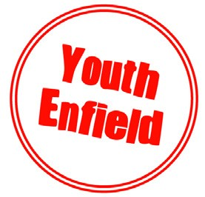
EARLY HELP SUBSTANCE ABUSE
Need advice, guidance & support with substance misuse? Are you 11-19?
WHAT WE OFFER
Drop in service for general advice
1:1 sessions
Harm reduction advice and sign posting
Group workshops
Advice for parents/carers
PONDERS END YOUTH CENTRE
CRAIG PARK YOUTH CENTRE
ALAN PULLINGER YOUTH CENTRE

We are a service that can
Further information
To book an appointment outside of the drop in sessions
Email:
substancemisusereferrals@enfield.gov.uk
Aaron.saffrey@enfield.gov.uk
Phone: 07356 180 272

