Bring Your Own Device (BYOD) Policy
XXXXXX School
[This is a proposed template policy intended as a guide allowing individual schools to reflect their own policies and approaches]

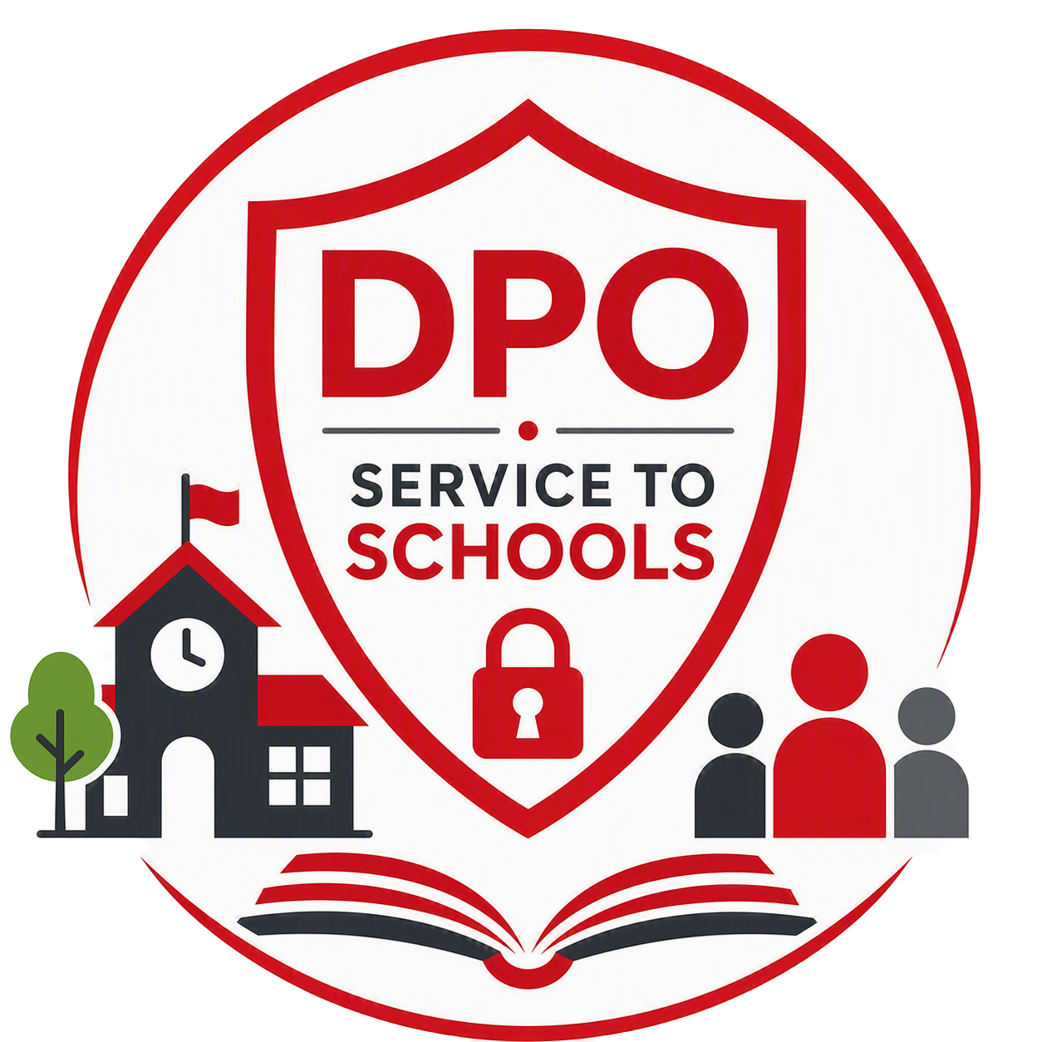

Reviewer | [School lead] | Classification | Official | Date of First Issue | 14.09.2026
Owner | Board of Governors | Issue Status | Final | Date of Latest Re-Issue | 14.09.2026
Version | 1.0 | Page | 1 of 8 | Date Approved by Governors | XX.XX.2026
Author | Mark Agnew, LBE Deputy Data Protection Officer |  |  | Date of Next Review | XX.XX.2027

Contents

1 Introduction 3
2 Scope of the Policy 3
3 Use of Devices 4
4 Access to the School’s Internet 4
5 Access to the School’s IT Systems 5
6 Monitoring the Use of Personal Devices 5
7 Security of Devices 6
8 The Use of Cameras and Audio Recording Devices 6
9 Smart Glasses/Wearable Devices 7
10 Medical and Accessibility Exemptions 7
11 Policy Review 8

Introduction

  - We recognise that mobile technology can offer significant benefits for both staff and students, supporting teaching, learning and communication. However, the widespread availability of personal technology has also introduced new challenges within the school environment. As a school, we welcome the use of this technology, provided it is used responsibly and appropriately. This policy applies to anyone who wishes to use a device not owned by the school (for example, a personal device) to access school systems, data or information.

  - We have a responsibility to protect the information entrusted to us by pupils, parents and guardians, staff and contractors, visitors, and our government and statutory partners. To do this effectively, we must ensure that:

- We comply with UK legislation relating to the management and protection of personal data.
- The school's [Data Protection] and [Information Security] policies are followed at all times.
- Where information belonging to third parties is accessed or used, any requirements or conditions set by the data owner are fully respected and adhered to.

  - This policy is designed to help protect the security and integrity of both school data and the systems used to access it. It does not automatically grant permission to use a personal device for school purposes. Instead, it outlines the organisational and technical requirements that apply where such use has been authorised through the [Staff Code of Conduct], [Pupil Behaviour Policy], or any guidance and expectations communicated to visitors.

  - Please note that the school reserves the right to refuse permission for staff, students or visitors to use personal devices on school premises, or to access school systems and data.

Scope of the Policy

  - This policy applies to anyone using a personal device to access the internet through the school's network or to access school information. This is commonly referred to as "Bring Your Own Device" (BYOD).

  - Personal devices include laptops, tablets, smartphones, USB storage devices, wearable technology, such as smartwatches and Apple Watches, and any other portable device capable of connecting to Wi-Fi or the internet that is not owned by the school or recorded on the school's asset register.

  - Anyone using a personal device to connect to the school's internet services or access information held on school systems is responsible for reading, understanding, and complying with this policy.

  - Users are expected to:

- Help protect children and young people from harm.
- Understand what constitutes inappropriate or unacceptable use.
- Take reasonable steps to minimise the risks associated with BYOD.
- Help protect the school from cyber security threats and incidents.
- Report any suspected misuse, security concerns or breaches immediately.
- Act responsibly and maintain high standards of professional conduct.
- Respect boundaries at all times.

Use of Devices

  - Permission must be obtained before a personal device can be connected to the school's network. The school reserves the right to refuse permission for staff, pupils, or visitors to use personal devices on school premises.

  - Staff, pupils, and visitors remain responsible for their personal devices at all times. The school cannot accept responsibility for the loss, theft or damage, or upkeep of a personal device, or any storage media associated with it (such as removable memory cards), regardless of the cause. This includes any loss or corruption of data stored on the device.

  - Any loss or theft of a personal device that has been used to access school systems or information must be reported to the school as soon as possible. These incidents will be recorded and reported to the data protection lead.

  - Please note that the school is unable to provide technical support for personal devices. Any costs associated with using a personal device to access the school's systems, applications or services, including mobile data charges or other charges incurred through a personal contract, remain the responsibility of the device owner.

  - [If applicable] For pupils the primary purpose of using personal devices in school is to support teaching and learning. Limited personal use during non-teaching times, such as checking emails, reading messages, or other reasonable personal communication, may be permitted. The use of personal devices during lessons is entirely at the discretion of teaching staff, and pupils must use their devices only as directed by their teacher.

  - Personal devices must not be used in a way that distracts staff or pupils or disrupts teaching and learning. Activities that are unrelated to schoolwork, such as playing games or using entertainment apps, are not permitted during lesson time and may only be allowed during break or lunchtime in accordance with school rules.

  - Individuals must not attempt to bypass, undermine or interfere with the school's network security arrangements. This includes, but is not limited to, setting up proxy services, using virtual private networks (VPNs) without authorisation, downloading software designed to circumvent security controls, or otherwise attempting to gain unauthorised access to systems or services.

Access to the School’s Internet

  - Access to the school's internet is granted at the school's discretion and may be withdrawn at any time if a user is found to be using the network inappropriately, or in breach of this or other relevant policies. While the school takes reasonable steps to provide a secure network environment, it cannot guarantee the security of the wireless network. Staff, pupils and visitors access and use the network at their own risk.

  - Users must not download apps, software, or other applications while connected to the school's network unless specifically authorised to do so. The school is not responsible for the content of any downloads made to personal devices whilst connected to the network, and accepts no liability for any loss of data, device malfunction, or damage resulting from the use of the school's network.

  - [If applicable] The school provides a guest wireless network that staff, pupils and visitors may use, with permission, to connect their personal devices to the internet. Access to this service is subject to the requirements set out in this policy and any other relevant school policies.

Access to the School’s IT Systems

  - Where staff or pupils are authorised to access school IT systems using personal devices, the school may require additional security measures to be enabled. This could include the use of [passwords, device encryption, multi-factor authentication, and the disabling of notifications on the lock screen where appropriate]. It is the responsibility of the device owner to ensure that their device is suitably secure for the intended use.

  - Individuals must not store personal data relating to staff, pupils, or any other individuals on personal devices, or on cloud storage services linked to personal accounts or devices.

  - Any unauthorised access to, disclosure of, or loss of confidential information must be reported to the [Head Teacher and/or data protection lead] as soon as possible, in line with the school's [Data Protection Policy and Data Breach Policy]. This includes the loss or theft of any personal device that has been used to access school systems or that may contain school-related personal data.

  - Before a personal device that has been used to access the school's network, systems, or cloud-based services is sold, transferred, shared, or given to another person, including a family member or spouse, all school-related data, emails, applications and system access must be completely removed from the device.

[You may wish to list the ICT services and applications that the school uses that could be accessed by an individual on their own device i.e]
  - Applications that could be accessed with permission on a personal device include, but are not limited to:

- E-mail. .
- Calendar
- Contacts
- Tasks
- Telephony, Meetings and Instant Messaging i.e. Teams / Skype etc
- File access and editing via SharePoint / Google Drive etc.
- Multi-factor authentication via Microsoft Authenticator etc
- Collaboration and group discussion via Yammer / Teams/ Slack etc.]

Monitoring the Use of Personal Devices

  - The school reserves the right to use appropriate monitoring and security technologies to detect and review the use of personal devices that are connected to, or used to access, the school's internet and IT systems. These measures are in place to help protect the security of school systems, services, and information.

  - Information that may be monitored includes, but is not limited to:

- Websites visited and the time and duration of those visits.
- Information entered into online forms.
- Files and information uploaded to or downloaded from websites and school systems.
- The content of emails sent through school-provided services.
- Network traffic, including peer-to-peer activity transmitted via the school network.

  - Monitoring will be carried out in accordance with relevant legislation, school policies, and operational requirements.

  - Any inappropriate, concerning, or potentially harmful content received through the school's IT systems or internet connection will be reported as soon as possible to the Head Teacher, IT lead and/or designated safeguarding lead, as appropriate.

Security of Devices

  - Users are expected to take all reasonable steps to prevent unauthorised access to their personal devices. This includes, but is not limited to, using a PIN, password, or biometric authentication to secure the device, and ensuring that it automatically locks after a short period of inactivity. Users are responsible for maintaining the security of any personal device used to access school systems, services or information.

  - User account details, usernames, passwords, PINs and any other credentials used to access the school's systems, applications, and services must be kept secure and always treated as confidential. These credentials are issued for individual use only and must never be shared with, disclosed to, or used by another person.

  - Where specific safeguarding, security, or safety considerations apply, the Head Teacher reserves the right to require staff, visitors, and other authorised adults to store personal devices in a secure location while on school premises. This may apply in designated areas or during particular activities where the presence of personal devices could increase safeguarding risks or compromise privacy and confidentiality, including controlled assessments and/or examinations. Unless special circumstances apply.

  - The Head Teacher also retains the discretion to determine whether personal devices may be taken into, or used within, particular areas of the school where enhanced safeguarding measures are necessary. All individuals are expected to comply with any such restrictions, which will be communicated as appropriate, and implemented in line with the school's safeguarding responsibilities and risk management procedures.

The Use of Cameras and Audio Recording Devices

  - Visitors and staff subject to this policy may [/may not] use their own mobile devices to take photographs, video, or audio recordings in the school. Recordings can only take place in line with HR policies and procedures.

  - No one will use mobile devices to record people at times when they do not expect to be recorded, and devices will not be used that would enable a third party acting remotely to take photographs, video, or audio recordings in school. Users must not use such devices to record, transmit, or post any of the following: photos, audio, or video of any person(s) within school without the explicit permission of the person(s) involved.

  - Individuals shall not distribute pictures or video or any other material relating to students or staff without their permission. Distribution can be as small as emailing/texting to one other person or as large as posting image or video online.

Smart Glasses/Wearable Devices

  - [Recommended] As technology continues to evolve, new devices are reshaping the way we connect, learn, and share information. One of the latest innovations is Smart Glasses; eyewear that looks like ordinary spectacles but can include built-in cameras, microphones, and internet connectivity.

  - Smart glasses can discreetly record, live-stream, or share content instantly, and therefore can pose risks to pupils, staff, and visitors. In response to this, and to ensure our community remains a safe and secure place, the use of smart glasses, and similar wearable devices, will not be permitted on school grounds by pupils, parents, visitors, or staff.

Medical and Accessibility Exemptions

  - The school recognises that some students may require access to a personal device during the school day for medical reasons. This may include, but is not limited to, devices connected to medical equipment; health monitoring applications; communication tools required as part of a diagnosed medical condition; or other healthcare-related needs supported by a medical professional.

  - Requests for a medical exemption should be submitted to the school with appropriate supporting evidence. Any approved arrangements will be confidentially documented and reviewed periodically to ensure they continue to meet the student's needs while maintaining a safe and positive learning environment.

  - The school is committed to ensuring that all students can access learning and participate fully in school life. Students with disabilities, special educational needs, or other identified accessibility requirements may be granted an exemption from the BYOD policy where a personal device forms part of their agreed support arrangements. Such devices may be used to access assistive technologies, communication aids, specialist software, or other reasonable adjustments identified through an Education, Health and Care Plan, or professional recommendation.

  - All accessibility exemptions will be considered on an individual basis and managed in partnership with pupils, parents and carers, and relevant school staff. Where an exemption is approved, the school may set reasonable conditions regarding the storage, use, and supervision of the device to ensure that safeguarding, privacy, security, and educational requirements are maintained. Any such arrangements will be proportionate to the student's needs and kept under regular review.

Policy Review

  - [Recommended] This policy will be reviewed annually by the senior leadership team and updated as necessary to reflect changes in technology, emerging cyber security threats, legal and regulatory requirements, and recognised best practice.

  - Any revisions to the policy will be submitted to the Board of Governors for approval. The Board of Governors is also responsible for providing strategic oversight of the school’s cyber security arrangements and for ensuring appropriate assurance is in place regarding compliance with this policy and related security requirements.

