Cyber and Information Security Policy
XXXXXX School
[This is a proposed template policy intended as a guide allowing individual schools to reflect their own policies and approaches]

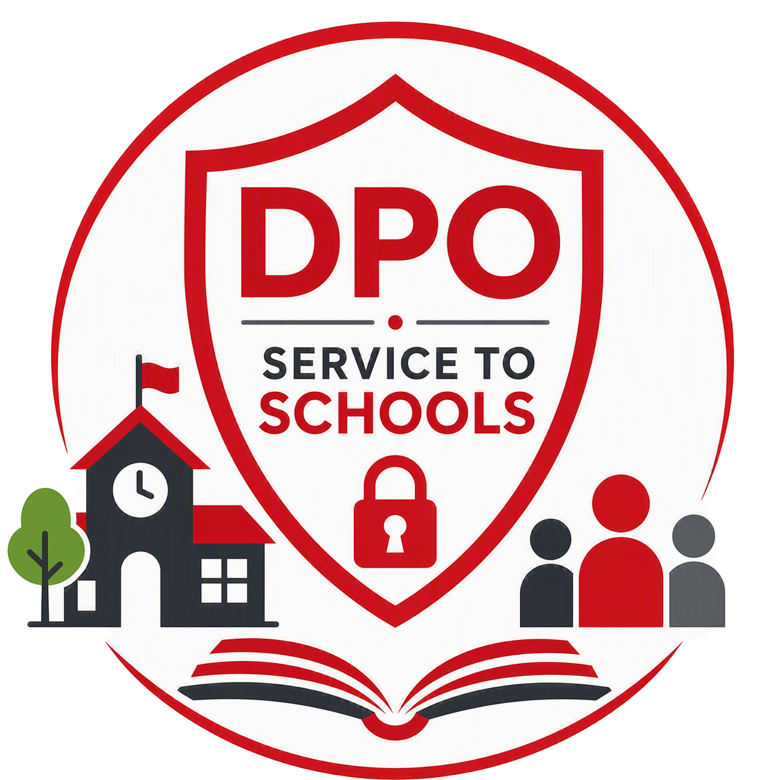

Reviewer | [School lead] | Classification | Official | Date of First Issue | 07.08.2018
Owner | Board of Governors | Issue Status | Final | Date of Latest Re-Issue | 14.09.2026
Version | 2.0 | Page | 1 of 9 | Date Approved by Governors | XX.XX.2026
Author | Mark Agnew, LBE Deputy Data Protection Officer |  |  | Date of Next Review | XX.XX.2027

Contents

1 Introduction 3
2 Scope of the Policy 3
3 Roles and Responsibilities 4
4 Cyber Security 5
5 Email and Data Security 6
6 Cyber Security Incident Management Plan 7
7 [Remote Users] 8
8 Governing Regulations 8
9 Policy Violations 8
10 Policy Review 9

Introduction

  - Data and information are valuable assets that play a vital role in the effective delivery of education and the day-to-day operations of the school. However, the use and storage of information also present risks relating to data protection, online safety, and safeguarding. We are committed to ensuring that information is managed appropriately and securely, giving staff, pupils, and parents confidence that privacy is respected and personal information is handled professionally and responsibly.

  - Everyone has a responsibility to help protect the information and data entrusted to the school. The secure operation of the school depends on information being kept safe, accurate, and secure. We are committed to using technology and IT systems in a way that complies with legal requirements and protects confidentiality, privacy, and individual rights.

  - This policy supports the school's approach to business continuity, data protection, and cyber security. It explains the principles and expectations that govern the use of technology and information and supports compliance with the UK General Data Protection Regulation (UK GDPR), the Data Protection Act 2018 (DPA 2018), the Department for Education's Digital and Technology Standards for Schools and Colleges, and other relevant legislation and guidance.

  - The policy applies to all pupils, staff, volunteers, contractors, visitors and any other individuals who use, or are granted access to, the school's networks, systems, devices or digital services. Its purpose is to promote the safe, secure, and responsible use of technology while helping to protect the school community from cyber threats, data breaches, safeguarding risks, and potential financial or reputational harm.

  - This policy should be read alongside other School policies and procedures relating to information governance and technology use, including, but not limited to:

- [E.g. Data Protection Policy
- Data Breach Policy
- Bring Your Own Device (BYOD) Policy
- Any other relevant information security or safeguarding policies.]

Scope of the Policy

  - This policy applies to all staff, contractors, volunteers, visitors, and anyone who has permanent or temporary access to the school's network, accounts, systems, services or hardware. All users are responsible for reading, understanding, and complying with the requirements set out in this policy.

  - While this policy applies to everyone, the school recognises that pupils may need additional guidance and support. As part of their education, pupils will be taught how to use technology safely, responsibly and securely, helping them to develop the knowledge and skills needed to make effective use of IT systems both in school and beyond.

Roles and Responsibilities

  - It is the responsibility of all members of staff to adhere to this policy, standards and procedures. It is the school’s responsibility to ensure the security of their information, ICT assets and data. Below are some of the specific roles and their responsibilities in relation to this policy.

Senior Information Risk Owner (SIRO)
  - The Head Teacher, or a delegated member of the senior leadership team, is typically responsible for leading and overseeing information security and risk management across the school. This includes maintaining relevant policies, promoting information security standards and good practice, and ensuring that staff receive appropriate training, guidance, and support to help them understand their responsibilities when handling school information, particularly information that is sensitive or confidential.

  - In addition, the SIRO acts as the school's main point of contact for information security matters and is responsible for ensuring that any suspected or actual information security incidents are reported, investigated, and managed appropriately. Where required, this includes notifying the senior leadership team, the data protection lead, and the Chair of Governors in accordance with the school's policies and procedures.

  - The SIRO for this school is XXXX

Data Protection Lead
  - The data protection lead supports the school in meeting its data protection obligations and promoting good information governance practices. This includes advising the school and its staff on their responsibilities under data protection legislation, providing guidance on Data Protection Impact Assessments (DPIAs), and monitoring the effectiveness of the school's data protection arrangements.

  - The data protection lead also helps to identify and assess data protection risks, recommends appropriate safeguards to mitigate those risks, and maintains the records, evidence and documentation required to demonstrate the school's compliance with data protection legislation.

  - The data protection lead for this school is XXXX

[IT Manager] or appropriate role
  - The IT Manager and IT team are responsible for implementing and maintaining the school's technical security controls. Their role includes monitoring the school's networks and systems, managing user access permissions, applying updates and security patches, and responding to cyber security incidents and technical issues. They play a key role in helping to protect the school's systems, data, and services from security threats and ensuring that technology remains secure, reliable, and fit for purpose.

  - The [IT Manager] for this school is XXXX

School Governors
  - The Board of Governors are responsible for providing overall oversight of the school’s cyber security arrangements, approving relevant policies, and ensuring that regular reviews are carried out to monitor compliance and maintain effective security practices

Staff and Users
  - Everyone has a responsibility to help protect the information and data entrusted to the school. All users are responsible for reading, understanding, and complying with the requirements set out in this policy and to adhere to required standards and procedures.

Cyber Security

  - Given the potentially serious consequences of a cyber security breach, it is important that the school takes appropriate preventative measures and that all staff, pupils, and other users follow the requirements and guidance set out in this policy.

  - To help protect its information, systems, and services from cyber threats, the school has implemented a range of technical and organisational security measures. These measures are designed to reduce risk, safeguard sensitive information, support the secure use of technology, and maintain the availability and integrity of school systems and data.

  - Examples of the security measures in place include, but are not limited to:

- [ e.g. firewalls;
- anti-virus software;
- anti-spam software;
- filtering;
- secure data backup;
- encryption;
- deleting or disabling unused/unnecessary user accounts, and;
- using strong passwords.]

  - While technical security measures play an important role in protecting the school's systems and information, they are not enough on their own. Effective cyber security also relies on the actions and awareness of the people who use our systems. For this reason, the school's approach to cyber security includes both technical controls and measures designed to address the human risks associated with cyber-crime.

  - [Recommended] All staff will receive appropriate cyber security and information governance training as part of their induction, with refresher training provided as required. Additional training and guidance may be provided where there are changes to legislation, regulations or school policies, where significant new threats are identified, or following an incident affecting the school or any third party with whom information is shared.

  - In some circumstances, it may be necessary to restrict access to information to a limited number of individuals to help protect sensitive data and reduce security risks. This may be supported through a combination of organisational procedures and technical access controls.

  - All users are expected to understand the risks posed by cyber-crime, cyber-attacks and information security failures, and to take reasonable steps to reduce those risks. This includes following school policies and adopting good security practices, such as being cautious of suspicious emails, links and attachments, and avoiding the forwarding of chain messages, spam, or inappropriate content.

  - In addition, all users are required to use strong, unique passwords to protect their accounts and always keep those passwords confidential. Passwords must not be shared with anyone else, and no other person should be allowed to access School systems using your account or login credentials.

  - Users must only access school networks, systems and services using devices that are owned by the school [if applicable] or have been specifically authorised for use by the school. Users must not disable, interfere with, or attempt to bypass any security controls, software or safeguards that have been installed on school devices, networks or systems.

  - Any concerns relating to a potential security breach, suspicious activity, cyber security threat, or mistake that could result in a security incident must be reported to the [SIRO/ Head Teacher/ senior leader] as soon as possible after it is identified. Prompt reporting helps the school respond quickly and minimise any potential impact.

  - The school consider the following to be a misuse of systems and equipment:

- any malicious or illegal action carried out against the school or using the Trust’s systems;
- accessing inappropriate or illegal content within school premises or using school equipment;
- excessive personal use of school’s systems or network during working hours;
- removing data or equipment from school premises or systems without permission;
- circumventing technical cyber security measures implemented by the school; and
- failing to report a mistake or cyber security breach

Email and Data Security

  - Email remains one of the most common ways that phishing attacks, scams, and malicious software are delivered. To help protect both individual users and school systems, all users should take care when sending, receiving and responding to emails. All users are expected to:

- Keep their email application or web browser up to date and ensure that the latest security updates are installed.
- Avoid opening attachments or clicking on links in emails where the content is unexpected, unclear or insufficiently explained.
- Treat emails with clickbait-style subject lines, offers of prizes, unsolicited advice or similar messages with caution.
- Check the sender's name and email address carefully to confirm that the message has come from a legitimate source.
- Be alert to common signs of phishing or fraudulent emails, such as spelling and grammar mistakes, unusual requests, excessive use of capital letters or punctuation, or a sense of urgency.
- Only respond to emails where the sender and subject matter are recognised and appear genuine.

  - If a user is unsure whether an email is legitimate or safe, they should contact the school's IT team before opening any attachments, clicking links or responding to the message.

  - The transfer of information also introduces security risks and must be carried out carefully. All users must:

- Avoid transferring sensitive or confidential information to other devices, systems or accounts unless there is a clear business need to do so.
- Seek advice from the school's IT team before carrying out large-scale or bulk data transfers.
- Share confidential information using approved school systems and networks, rather than public Wi-Fi networks or unauthorised private connections.
- Avoid using USB drives or other removable storage devices wherever possible. Where their use is necessary, only school-approved and encrypted devices should be used.
- Ensure that any individual or organisation receiving information is authorised to do so and has appropriate security measures in place to protect it.
- Never download or save confidential School information to a personal device unless specifically authorised.
- Report any suspected scams, phishing attempts, malware infections, security incidents or data breaches immediately.

  - Prompt reporting is essential. The school's IT team relies on timely information about scams, suspicious emails, security incidents, and potential cyber-attacks so that appropriate action can be taken to protect systems, data, and users. All users therefore have a responsibility to report any concerns as soon as possible.

Cyber Security Incident Management Plan

  - In line with National Cyber Security Centre guidance, the school's incident management process follows four key stages:

- Containment and recovery: This involves investigating the incident, taking immediate steps to limit any impact, and using appropriate staff and resources to contain the issue and recover any lost data where possible. The school will notify its insurers as soon as reasonably practicable of any circumstances that may give rise to a claim under relevant insurance policies. Consideration will also be given to whether the school's business continuity plan needs to be activated.

- Assessment of ongoing risk: This stage involves establishing exactly what happened, identifying the data, systems or services affected, and determining whether appropriate protections were in place. The nature and sensitivity of any affected data will be assessed, along with any actual or potential consequences arising from the incident.

- Notification: The school will assess whether the incident needs to be reported to relevant regulators or authorities, such as the London Borough of Enfield, the Information Commissioner (ICO) or the National Crime Agency. Where appropriate, affected staff, parents, pupils and other stakeholders will also be informed.

- Evaluation and response: Following the incident, the school will review the circumstances, identify any lessons learned, and consider what improvements can be made to strengthen security, reduce future risks and improve resilience.

  - Please note that where a cyber security incident involves, or is suspected to involve, a personal data breach, the school will also follow the procedures set out in its Data Breach Policy.

[Remote Users]

[If applicable]

  - Users who access school systems and information remotely must comply with the requirements of this policy at all times. When working remotely, users are responsible for ensuring that school information remains secure and that all applicable data protection, encryption, and security requirements are followed.

  - Users must take reasonable steps to ensure that the network they are using is secure and suitable for accessing school systems and data. Wherever possible, remote access should only be carried out using school-issued devices that are configured and managed in line with the school's security requirements.

  - Users are encouraged to seek advice from the school's IT team if they are unsure about the security of their device, network connection or remote working arrangements.

Governing Regulations

  - This Policy has due regard to relevant regulations and guidance including, but not limited to:

- Data Protection Act 2018 (DPA 2018)
- Network and Information Systems (NIS) Regulations (2018)
- The UK NIS Regulations are designed to improve the overall cybersecurity posture of
- essential services and digital service providers, aligning with the EU NIS Directive.
- Cybersecurity Essentials (Cyber Essentials)
- The Computer Misuse Act 1990
- ISO/IEC 27001
- Information Commissioner’s Office (ICO)
- National Cyber Security Centre (NCSC)

Policy Violations

9.1 All employees are expected to always follow this policy and those who cause security breaches, especially deliberate or serious breaches, may face disciplinary action in accordance with the school’s disciplinary policy and procedure.

9.2 Examples of deliberate or serious breaches of this policy and examples of misuse include, but not limited to:

- Knowingly disclose login information to an unauthorised third party.
- Inappropriate disclosure of personal data.
- Knowingly installing software on school devices that hasn’t been approved by IT which leads to a breach.
- Allowing the use of school devices by unauthorised third parties.
- Storing data on insecure media such as removable media that leads to a breach.

Policy Review

  - [Recommended] This policy will be reviewed annually by the senior leadership team and updated as necessary to reflect changes in technology, emerging cyber security threats, legal and regulatory requirements, and recognised best practice.

  - Any revisions to the policy will be submitted to the Board of Governors for approval. The Board of Governors is also responsible for providing strategic oversight of the school’s cyber security arrangements and for ensuring appropriate assurance is in place regarding compliance with this policy and related security requirements.

