Data Breach Policy
XXXXXX School
[This is a proposed template policy intended as a guide allowing individual schools to reflect their own policies and approaches]



Reviewer | [School lead] | Classification | Official | Date of First Issue | 27.06.2018
Owner | Board of Governors | Issue Status | Final | Date of Latest Re-Issue | 14.09.2026
Version | 2.0 | Page | 1 of 7 | Date Approved by Governors | XX.XX.2026
Author | Mark Agnew, LBE Deputy Data Protection Officer |  |  | Date of Next Review | XX.XX.2027

Contents

1 Introduction 3
2 Scope of the Policy 3
3 What is a Data Breach? 3
4 Reporting a Data Breach 4
5 Data Breach Assessment 5
7 Steps to take During a Data Breach 5
8 Policy Review 7

Introduction

  - The school is required under the Data Protection Act 2018 and the UK General Data Protection Regulation to protect the personal data it processes and to ensure that appropriate measures are in place to maintain its confidentiality, integrity and security. We are committed to handling personal information responsibly and in accordance with our legal obligations, ensuring a consistent and compliant approach to data protection across all areas of our operations.

  - This policy sets out the approach that must be followed in the event of a data breach or suspected data breach. It is designed to help staff identify, report, manage and respond to breaches effectively, minimise any potential harm to individuals, and ensure that the school meets its statutory and regulatory responsibilities. Prompt and appropriate action is essential to protect the rights of individuals, maintain trust and confidence, and reduce the risk of further unauthorised access, disclosure, loss or misuse of personal information.

Scope of the Policy

  - This policy applies to all data breaches, and suspected data breaches, involving information processed by or on behalf of the school, regardless of whether the information is held electronically, in paper records, or in any other format. It covers all personal data processed in connection with the school’s activities, including information relating to pupils, parents, staff, governors, contractors and other individuals.

  - The policy applies to all members of the school workforce, including employees, agency workers, volunteers, contractors, consultants and any other person who handles personal data on behalf of the school. It sets out the responsibilities of individuals for identifying, reporting, and responding to actual or suspected data breaches, and establishes a framework for the management, investigation, and resolution of such incidents.

  - The whole school shares responsibility for protecting personal information and we all must ensure that any actual or suspected data breach is reported without delay in accordance with this policy.

What is a Data Breach?

  - A personal data breach is a security incident that results in the accidental or unlawful destruction, loss, alteration, unauthorised disclosure of, or access to, personal data that has been transmitted, stored or otherwise processed. Data breaches can occur for a variety of reasons, including cyber-attacks, malicious actions by individuals, human error, system failures, or accidental exposure of information.

  - Personal data breaches can take many forms. Examples include, but are not limited to:

- Sending personal data to the wrong recipient, for example where information relating to a pupil is accidentally sent to the wrong parent or guardian.
- Access to personal data by an unauthorised third party.
- Deliberate or accidental actions, or failures to act, by a data controller or processor that result in personal information being compromised.
- The loss or theft of devices containing personal data, such as laptops, mobile phones, USB drives, or paper records.
- The unauthorised alteration, deletion, or corruption of personal data.

  - Personal data breaches can cause significant harm to the individuals concerned. The unintended disclosure of sensitive information, such as health records, safeguarding information, or other confidential personal data, may have serious consequences for a pupil, their family, or members of staff.

  - Depending on the nature of the breach, individuals may suffer financial loss, emotional distress, reputational harm, or other adverse effects. Data breaches can also damage the school’s reputation and undermine the confidence of pupils, parents, staff and the wider community. A loss of trust may affect the school’s relationships with stakeholders and could result in increased scrutiny from regulators, authorities, and partners.

  - Maintaining strong data protection practices is therefore essential in preserving confidence in the school’s ability to safeguard personal information.

  - Under the UK GDPR and the Data Protection Act 2018, the Information Commissioner (ICO) has a range of enforcement powers where organisations fail to comply with their obligations. These powers include issuing warnings, reprimands and enforcement notices, requiring organisations to change their practices, ordering the restriction or deletion of personal data, and, in the most serious cases, imposing financial penalties. Schools may also face compensation claims from individuals who have suffered damage or distress because of a personal data breach, which can result in significant costs and management time.

  - In addition, data breaches can disrupt the school’s day-to-day operations. Investigating and responding to a breach can divert resources away from teaching, learning and support services. While system outages or loss of data may affect critical administrative and educational functions. For these reasons, all staff have a responsibility to help prevent data breaches, and to report any suspected or actual incidents immediately so that appropriate action can be taken.

Reporting a Data Breach

  - All suspected personal data breaches, including near misses, must be reported immediately upon discovery using the data breach Reporting form on The Hub and sent to the Council's Data Protection Officer (DPO). The contact email address for the Council's Data Protection Team is enfield.data.protection.officer@enfield.gov.uk.

  - Prompt reporting is essential to ensure that appropriate action can be taken to contain the incident, assess any risk to individuals, and determine whether any further steps are required under data protection legislation. When completing the form, staff should provide a clear description of what happened, including when the incident occurred, when it was discovered, and the type of personal data involved.

  - Staff should also provide their assessment of any potential risk to the affected individual or individuals, recognising that they are often best placed to understand the circumstances in which the breach occurred.

  - The form should detail any immediate actions taken to contain the breach, such as securing misplaced documents, recovering information, or obtaining confirmation that data sent in error has been deleted by the unintended recipient. Staff should also identify any lessons learned and any measures that have been, or will be, implemented to reduce the likelihood of a similar incident occurring in the future, such as staff awareness discussions, procedural changes, or additional security controls.

Data Breach Assessment

6.1 Upon receiving the data breach reporting form, each breach will be triaged by the DPO and the Data Protection Team, and categorised according to risk levels.

6.2 The investigating officer (the DPO or another member of the Data Protection Team) may deem it necessary to contact you further to review the form and to gain any clarifications needed about the breach.

6.3 Based on the information they will establish a risk rating by assessing the Impact, considering the nature of the data and the data subjects, and assessing the Likelihood, taking into account how the data was breached and who it was disclosed to or accessed by.
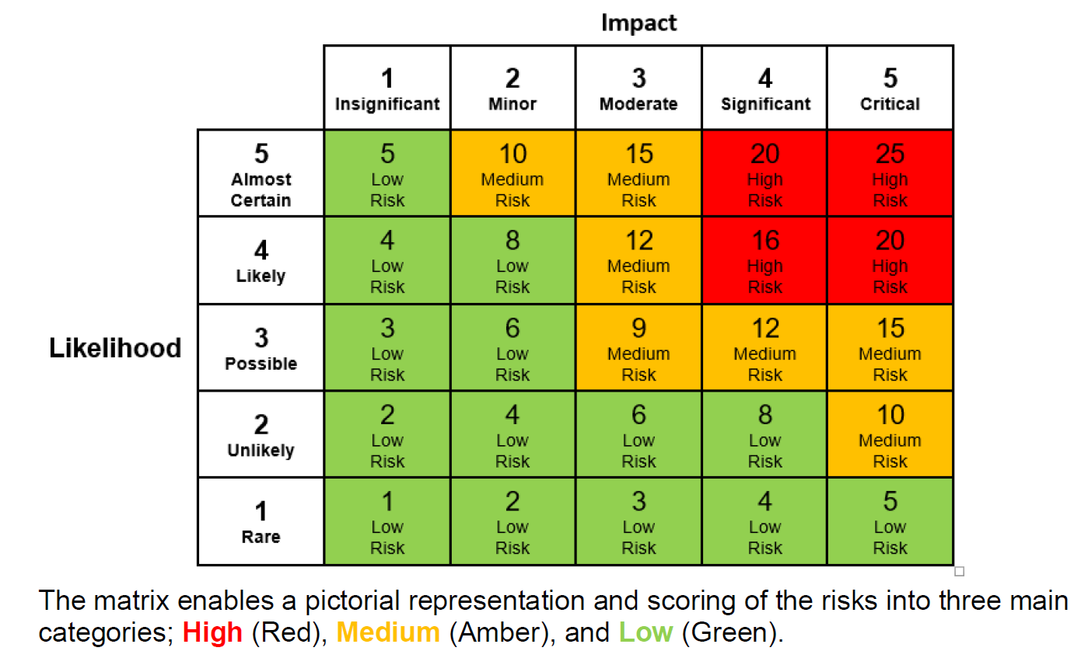

6.4 In addition, they will take into consideration other factors when assessing the risk:

- Professional’s view of the risk – e.g. social worker, safeguarding lead.
- Relationship with the data subject.
- Data subject vulnerabilities.
- The individuals who have been given access to the data.
- Steps already taken to mitigate the risk.

Steps to take During a Data Breach

7.1 Regardless of the severity of a personal data breach, the school needs to follow a structured process to ensure that the incident is managed effectively, risks are assessed, and any required actions are taken promptly.

7.2 Immediate Containment and Recovery: Upon becoming aware of a data breach, as well as reporting it, immediate action must be taken to contain the incident and minimise any further risk. Depending on the nature of the breach, this may include securing or shutting down systems, revoking access permissions, recovering information that has been disclosed in error, or contacting third-party service providers for assistance. Containment is essential to reduce the potential impact on affected individuals and to prevent any further loss, alteration or unauthorised disclosure of personal data.

7.3 Where personal data has been shared incorrectly, the school should take reasonable steps to recover the information and obtain written confirmation that the data has been deleted, destroyed, or will not be used or shared further.

7.4 Triage and Assessment of Risks: Once a breach has been reported and any immediate containment actions have been taken, an assessment will be carried out to determine the level of risk posed by the incident. This assessment should consider the nature and sensitivity of the personal data involved, the number of individuals affected, the likelihood of harm occurring, and the potential impact on those individuals if the information is misused or disclosed further. Consideration should also be given to any operational, financial, or reputational impact on the school.

7.5 The Data Protection Team will review and triage all reported breaches to determine the appropriate level of response. This will include deciding whether the incident requires escalation to senior management, notification to the ICO, communication with affected individuals, or engagement with other relevant parties. The assessment process will ensure that breaches are managed consistently, proportionately, and in accordance with the school’s legal and regulatory obligations.

7.6 Notification: Where a personal data breach is assessed as presenting a risk to the rights and freedoms of individuals, the DPO will determine whether notification to the ICO is required.

7.7 Where notification is necessary, this must be made without undue delay and, where feasible, within 72 hours of the school becoming aware of the breach. Individuals affected by the breach must also be informed where there is likely to be a high risk to their rights and freedoms. Notifications should be clear, accurate, and tailored to the circumstances of the incident, providing sufficient information to enable individuals to understand the nature of the breach and any actions they may need to take.

7.8 Investigation, Route Cause Analysis and Documentation: Following containment of the breach, a thorough investigation must be undertaken to establish how the incident occurred and identify any underlying causes. The investigation should consider the circumstances leading to the breach, the effectiveness of existing controls, and whether any procedural, technical or human factors contributed to the incident. A record should be maintained throughout the investigation, including the nature of the breach, the personal data involved, decisions made, actions taken to contain and mitigate the incident, and any remedial measures implemented.

7.9 Lessons learned should be captured throughout the investigation to support continuous improvement and help prevent similar incidents from occurring in the future. The findings of the investigation, including any recommendations for improvement, should be documented and retained as part of the school’s management records.

7.10 Evaluation and Response: Following completion of the investigation, the DPO will review the findings, outcomes and lessons learned to determine whether any further action is required.

7.11 This review will consider the root causes of the incident, the effectiveness of the response, and whether any trends or recurring issues have been identified that may present a wider organisational risk. Actions may be identified such as amendments to policies, processes and procedures, additional staff training, improvements to technical controls, or the implementation of new safeguards to reduce the likelihood of similar incidents occurring in the future.

Policy Review

  - [Recommended] This policy will be reviewed annually by the senior leadership team and updated as necessary to reflect changes in technology, emerging cyber security threats, legal and regulatory requirements, and recognised best practice.

  - Any revisions to the policy will be submitted to the Board of Governors for approval. The Board of Governors is also responsible for providing strategic oversight of the school’s cyber security arrangements and for ensuring appropriate assurance is in place regarding compliance with this policy and related security requirements.

